Response to the Reviewers’ Comments for TIA-2026-IPCC-0540
Manuscript Title: Design and Implementation of a Non-coupled Integrated Transformer for a Two-phase Interleaved Flyback PFC Rectifier

Aug xx, 2026

Dear Editor,

We would like to express our sincere appreciation to the reviewers for their constructive and insightful comments on our manuscript. The manuscript was revised in accordance with point-by-point answers to all the questions and suggestions.
- Pages x to x correspond to Reviewer #1’s comments.
- Pages x to x correspond to Reviewer #2’s comments.
- Pages x to x correspond to Reviewer #3’s comments.
We conducted additional simulations and experiments and revised the manuscript accordingly. In particular, we strengthened the literature review, clarified the new contributions beyond the conference version, and added additional frequency-domain characterization and thermal evaluation. We also updated the manuscript to improve clarity, consistency, and figure/table referencing based on the reviewers’ suggestions.

We hope the manuscript is now acceptable for publication.

Best Regards,
Sihoon Choi
Corresponding author,
Institute of Materials and Systems for Sustainability, Nagoya University
Email: choi.sihoon.w4@f.mail.nagoya-u.ac.jp

To Reviewer 1
We authors appreciate your valuable comments. The revised parts are indicated by red texts in the manuscript.

Comments to the Author
The manuscript presents a study of an interleaved flyback topology that employs a single transformer shared between the phases. The proposed approach is interesting, and the presented results demonstrate a reduction in magnetic component size compared to conventional solutions. However, several important technical aspects are not adequately addressed, making it difficult to assess the technique's actual superiority and practical benefits. Although a standard EE core is employed, the windings are distributed across all three legs of the magnetic core. This arrangement may complicate large-scale manufacturing, increasing production costs and assembly complexity. Furthermore, important technical aspects, such as the impact on leakage inductance, are not discussed and require further clarification. The following comments are provided to improve the manuscript:
- Leakage inductance is a critical issue in flyback converters, significantly affecting efficiency, power density, voltage stress, and overall converter performance. Due to the proposed winding arrangement, in which the primary and secondary windings do not appear to be fully overlapped, leakage flux may increase compared to conventional transformer designs. A detailed study quantifying the impact of the proposed winding configuration on leakage inductance is necessary for a proper evaluation of the proposed solution.
We sincerely thank the reviewer for highlighting this critical aspect. We completely agree that minimizing leakage inductance is essential for optimizing the efficiency, performance, and reliability of flyback converters. When winding this transformer, the thicker secondary windings are placed directly on top of the thinner primary windings. This overlapping arrangement minimizes the unused space within the window area and tightly couples the layers, effectively reducing the leakage inductance. Moreover, this overlapping resulted in a coupling coefficient $k_{N12-N34}$ of 0.970 for transformer $N_{12}-N_{34}$ and $k_{N56-N78}$ 0.979 for transformer $N_{56}-N_{78}$.We anticipate that these values can be further improved when utilizing automated, industrial-grade manufacturing techniques.

The figures shown about the transformer prototype, Fig. 2(b) and Fig. 10(b), is a representation of the general winding structure. This was so that the location of each winding and winding direction can be easily pinpointed. We apologize if this graphical simplification gave the impression that the windings were not physically overlapped in the actual prototype. To clarify this for readers, we have added an explanatory note to Section II-A of the manuscript where the detailed transformer winding structure is first introduced. We have clarified this in Section V-A of the manuscript. The revised portion of this section is shown in the response to Comment #5, as it relates to the actual photographs of the experimental prototype as well.

Before revision | After revision
(Section II-A, 2nd paragraph)  Half of $N_{12}$ and $N_{34}$ are wound at each outer leg with opposite polarity. Moreover, $N_{56}$ and $N_{78}$ are also wound with opposite polarity at the center leg. The transformer utilized an EE core with a center leg that has a cross-sectional area twice its outer leg, in accordance with conventional manufacturing specifications. | (Section II-A, 2nd paragraph)  Half of $N_{12}$ and $N_{34}$ are wound at each outer leg with opposite polarity. Moreover, $N_{56}$ and $N_{78}$ are also wound with opposite polarity at the center leg. It should be noted that Fig. 2(b) is a simplified representation of the winding structure, so that the location and direction of each winding can be easily pinpointed. The transformer utilized an EE core with a center leg that has a cross sectional area twice its outer leg, in accordance with conventional manufacturing specifications.

- No efficiency measurements are presented in the manuscript. Efficiency is a key performance indicator and is essential for assessing the effectiveness of the proposed topology. Experimental efficiency results over a range of output power levels should be included.
We sincerely thank the reviewer for pointing this out. We completely agree that efficiency is a fundamental metric for evaluating standard converter topologies. We have experimentally measured the efficiency of the converter over its entire operating range, up to an input power of 250 W using a Hioki PW8001 Power Analyzer. The resulting efficiency curve, shown in the figure below, has been added to the revised manuscript as a new figure Fig. 18. The efficiency peaks approximately 84.6% near full load in two-phase drive, and is discussed in the newly added Section V-C.

A direct experimental efficiency curve for the conventional discrete setup was not included, as this physical prototype was constructed strictly as a proof-of-concept to validate magnetic decoupling as an integrated transformer. Because the primary objective of this paper is the verification of the magnetic structure, optimizing system-level efficiency was not our primary focus for this prototype. To ensure robust operation and protect the switches against surge voltages during these fundamental magnetic validations, standard RCD snubber circuits were utilized. The high-power dissipation inherent to these simple snubber circuits heavily limits the overall efficiency. Moreover, while the current prototype demonstrates stable operational performance, it has not yet undergone comprehensive core and winding optimization. We anticipate that the overall system-level efficiency can be significantly improved in future iterations through the use of active clamp circuits, or advanced control techniques, and targeted magnetic optimization.
Before revision | After revision
N/A | (after Section V-B)  C. System-level Efficiency of the Proposed Interleaved Flyback Rectifier with the Integrated Transformer  To evaluate the overall performance of the proposed topology, the system-level efficiency of the prototype converter was measured over a wide operating range up to an input power of 250 W. Fig. 18 illustrates the measured efficiency curve during two-phase interleaved operation. As shown, the converter achieves a peak efficiency of approximately 84.6% near full load.  It should be noted that the primary objective of this study was to experimentally validate the fundamental magnetic decoupling of the integrated transformer, rather than optimizing overall system-level efficiency. To ensure robust operation during these initial magnetic validations, standard RCD snubber circuits were utilized. losses associated with these snubber circuits are expected to have significantly reduced the measured efficiency. Consequently, while the current prototype successfully demonstrates theoretical volume reduction and independent magnetic operation between two phases, further system-level efficiency improvements are anticipated in future iterations through the implementation of active clamp circuits or control techniques and optimization of the integrated transformer design.    Fig. 18. Efficiency curve of the proposed interleaved flyback rectifier with the integrated transformer, up to full-load operation of 240 W.

- A comprehensive comparison with a conventional interleaved flyback solution is needed. Key performance indicators such as magnetic volume, efficiency, power losses, current ripple, and THD should be compared to substantiate the claimed advantages of the proposed approach.
We thank the reviewer for this valuable insight. Because the primary contribution of this paper is the introduction of a novel integrated magnetic structure, our analysis focuses heavily on the volumetric reduction of the magnetic components and the verification of independent phase operation without magnetic interference. Furthermore, because of the strict structural decoupling achieved, the converter can reliably operate with a single-phase drive under light-load conditions, allowing for a contribution towards improving light load efficiency with higher power density. Given that the primary scope of this research is the physical verification of this magnetic decoupling and the validation of the integrated core structure, we believe the current experimental prototype rigorously demonstrates the proposed concept.

We then address your concerns as follows. Because the fundamental (DCM) operation of the proposed flyback rectifier with an integrated transformer remains electrically identical to that of a conventional interleaved flyback converter with discrete transformers, key electrical parameters such as current ripple and THD are theoretically unaffected by the shared core structure. Each point of interest is further explained below:
- Magnetic Volume: As detailed in Section IV, our volume analysis is conducted using the area product (AP) method. We have found some errors in the derivation in the first version of the manuscript and have corrected it here. The proposed integrated transformer achieves a theoretical 16% volume reduction compared to a conventional discrete baseline. Because the integrated core handles both phases, its required area product is approximately twice that of a single conventional core. However, because core volume scales by $AP^{3/4}$, the volume of the integrated core scales by ${\left(2AP_{conv}\right)}^{3/4}$. In contrast, the volume of two separate conventional cores scales by $2×AP_{conv}^{3/4}$. This scaling law mathematically confirms a 16% spatial advantage when the core geometry is custom-tailored to the circuit specifications.
- Efficiency and Power Losses: Regarding the overall efficiency and power losses, the proposed integrated topology achieves a peak experimental efficiency of 84.6% near full load. Because the proposed topology operates identically to a conventional interleaved flyback PFC rectifier with discrete transformers, and the two transformers have been successfully decoupled with $k≈0.0005$, the semiconductor and switching losses are expected to be nearly identical to those of a discrete baseline. Consequently, the primary distinction in power dissipation between the proposed and conventional topologies lies strictly within the magnetic components. This is further explored in Comment #6.
- Current Ripple: Because the converter preserves identical DCM operation per phase, utilizing the same fixed switching frequency $f_{s}$, duty cycle $D$, and magnetizing inductance $L_{m}$ as a conventional setup, the phase currents are governed by the exact same electrical principles. Consequently, the input and output current ripples are fundamentally identical to a topology with discrete transformers, and the standard ripple cancellation benefits of two-phase interleaving are fully preserved.
- THD (Total Harmonic Distortion): Natural Power Factor Correction (PFC) is achieved via standard DCM operation, where the average input current inherently tracks the sinusoidal envelope of the AC main voltage. Because our structural decoupling guarantees that no cross-phase magnetic interference or transient disturbances occur, the integrated core does not distort the independent phase currents. Therefore, the THD performance is completely preserved and remains equivalent to that of a conventional interleaved flyback rectifier with discrete transformers.

PFC occurs naturally in DCM as per the following explanation. When the converter operates with a fixed switching frequency and a constant duty cycle $D$ across the AC line half-cycle, the peak and average currents drawn by each transformer phase during a switching period are directly proportional to the instantaneous rectified input voltage. Because there is no phase shift between the voltage and the drawn current, the total average input current inherently tracks the sinusoidal envelope of the AC input voltage, yielding a high-power factor under open-loop control.

The mathematical derivation confirming this inherent PFC behavior for the two-phase interleaved structure is detailed below:

Given a fixed switching frequency $f_{s}$ over the switching period $T_{s}$ and a constant duty cycle D across the AC line half-cycle, the peak current of the main switch for the first phase, $i_{S1_{pk}}\left(t\right)$, is determined by the instantaneous input voltage and is expressed as:

$$i_{S1_{pk}}\left(t\right)=\frac{v_{in}\left(t\right)DT_{s}}{L_{m}}$$

where $v_{in}\left(t\right)$ is the instantaneous rectified input voltage and $L_{m}$ is the magnetizing inductance of the active transformer phase.

The average input current drawn by the first phase over one switching period is calculated by integrating the triangular switch current waveform:

$$\left\langle i_{S1}\right\rangle \left(t\right)=\frac{1}{T_{s}}\int_{0}^{T_{s}}{i_{S1}}\left(τ\right)dτ=\frac{1}{T_{s}}\left(\frac{1}{2}i_{S1_{pk}}\left(t\right)DT_{s}\right)=\frac{v_{in}\left(t\right)D^{2}T_{s}}{2L_{m}}$$

Because the proposed converter utilizes a two-phase interleaved structure, the second phase operates identically to the first, shifted by 180 degrees. A symmetrical design is utilized in this flyback converter, where both phases share the same $L_{m}$, the average current drawn by the second phase is identical:

$$\left\langle i_{S2}\right\rangle \left(t\right)=\frac{v_{in}\left(t\right)D^{2}T_{s}}{2L_{m}}$$

The total average input current, $\left\langle i_{in}\right\rangle \left(t\right)$, drawn from the rectified input voltage is the sum of the average currents of both active phases:
$$\left\langle i_{in}\right\rangle \left(t\right)=\left\langle i_{S1}\right\rangle \left(t\right)+\left\langle i_{S2}\right\rangle \left(t\right)=\frac{v_{in}\left(t\right)D^{2}T_{s}}{L_{m}}$$
Since $D$, $T_{s}$, and $L_{m}$ are all constant values during steady-state open-loop operation, the total average input current is directly proportional to the instantaneous rectified input voltage:

$$\left\langle i_{in}\right\rangle \left(t\right)∝v_{in}\left(t\right)$$

Because $v_{in}\left(t\right)$ follows a rectified sinusoidal voltage $V_{in_{max}}|\sin\left(2πf_{line}t\right)|$), the input current inherently tracks the sinusoidal shape of the AC mains voltage. Consequently, the converter naturally achieves PFC in DCM without requiring a dedicated active current-shaping control loop. This is seen in the experimental waveform in Fig. 15(a), where we could see from the macroscopic view that $i_{S1}$ and $i_{S2}$ are in-phase with the AC input voltage $v_{in}$.

We expanded the discussion on THD and current ripple in the last part of Section II-A of the manuscript as follows.

Before Revision | After Revision
N/A | (after the last paragraph of Section II-A)  Because the proposed integrated transformer achieves magnetic decoupling, the fundamental DCM operation of the converter remains electrically identical to a conventional interleaved topology utilizing discrete transformers. As a result, the standard electrical benefits of two-phase interleaving are fully preserved. Utilizing the same fixed $f_{s}$, $D$, and $L_{m}$, the phase currents are governed by identical electrical principles, ensuring that input and output current ripple cancellation is maintained. PFC and Total Harmonic Distortion (THD) are expected to be similar performance expected from a conventional discrete setup.

- Experimental load transient results should be provided to demonstrate the dynamic performance of the converter and to verify the claimed decoupling between phases under transient operating conditions.
We sincerely thank the reviewer for this valuable suggestion. We completely agree that verifying the decoupling between phases under transient operating conditions is a critical concern to ensure the reliability and stability of the integrated magnetic transformer.

To directly address the concern regarding dynamic states, it is essential to highlight that the decoupling is geometrically enforced. By dividing the transformer $N_{12}-N_{34}$ turns symmetrically across the two outer legs and intentionally winding them with opposite polarities, the arrangement creates strictly orthogonal flux paths. This causes flux cancellation in the center leg. Therefore, the flux generated by $N_{12}-N_{34}$ circulates exclusively between the outer legs, while the flux from $N_{56}-N_{78}$ on the center leg splits evenly and returns through the outer legs without inducing a net voltage in the opposing windings.

Because this magnetic decoupling relies on the winding geometry, we successfully achieved a negligible inter-phase coupling coefficient of $k≈0.0005$ in our experimental prototype. We acknowledge that during a severe load transient, the rapid changes in current ($di/dt$) introduce high-frequency harmonics, potentially extending into the MHz range. It is theoretically possible that the decoupling might slightly degrade at these extremely high frequencies due to parasitic elements and non-ideal flux distribution. However, the magnitude and energy of these high-frequency components are very small compared to those in the fundamental operating frequency range, where the strict decoupling characteristics are fully maintained. Because the dominant energy remains in the decoupled frequency spectrum, any minor high-frequency cross-coupling will have a negligible impact on the overall circuit operation.

Therefore, even during a transient response, while the dynamic performance may not be exactly identical at the highest frequencies, it is expected to be highly similar to that of a conventional discrete configuration. We expect that the fundamental stability of the converter is preserved, allowing standard control methods to be applied. We have also provided our insights into this in the last part of Section V-A. Please see Comment #5 for the revised portion.

- A photograph of the experimental prototype, including identification of the main components, should be included. This information is important for evaluating the practical implementation, overall size, and power density of the proposed converter.
We thank the reviewer for this valuable suggestion. To provide a clearer perspective on the practical implementation, overall footprint, and power density of the proposed converter, we have added a photograph of the evaluation board to the revised manuscript (Fig. 11). As shown in the figure, the primary and secondary side boards of the converter were separated to facilitate simpler connection to the transformer and also experimental verification as there were many probes to be used. The assembly process for the integrated transformer is shown in Fig. 12. Fig. 12(a) gives an idea of the overlapping described in the reply to Comment #1 for the reduction of leakage inductance through the improvement of coupling. The windings are wound around the coil formers first as shown in Fig. 12(b), which were created through the use of a 3D printer, and are finally placed on the EE-core as shown in Fig. 12(c).

Furthermore, to fully clarify the experimental setup, we have explicitly detailed the precision measurement equipment, including the specific power supplies, power analyzer, oscilloscope, and probes utilized, in Section V-A of the revised manuscript.

Before revision | After revision
(Section V-A, 1st paragraph)  A prototype two-phase interleaved flyback rectifier, shown in Fig. 10(a) operating in DCM, was built to verify the operation of the integrated transformer. The prototype integrated transformer, shown in Fig. 10(b), was also designed using the proposed method. The specifications of the two-phase interleaved flyback rectifier and transformer are shown in Tables IV and V, respectively. The transformer parameters were characterized using a Hioki IM3536 LCR meter at 100 kHz. The coupling coefficients of the transformers $k_{N12-N34}$, $k_{N56-N78}$, and $k_{N12-N56}$ were derived from the mutual inductance obtained after connecting the respective transformer windings in series-aiding and series-opposing configurations. The coupling coefficient between the two flyback transformers $k_{N12-N56}$ is 0.0005, showing that the coupling was almost eliminated. | (Section V-A, 1st paragraph to 3rd paragraph)  A prototype two-phase interleaved flyback rectifier, with the circuit schematic shown in Fig. 10(a), was built to verify the operation of the integrated transformer operating in DCM. A photograph of the prototype evaluation board is provided in Fig. 11(a), with the primary and secondary side separated for simple implementation. Because the fundamental operating principles of the converter remain identical to a conventional discrete setup, standard closed-loop modulation methods are directly applicable. Therefore, the experimental evaluation was intentionally conducted using open-loop control with a fixed duty cycle decided using (28).  The prototype integrated transformer, represented in Fig. 10(b), was also designed using the proposed method. To strictly minimize leakage inductance, the primary and secondary windings of the transformer for each respective phase were physically overlapped on their designated legs. The EE-core used for the prototype is shown in Fig. 12(a). The windings are wound around lab-made coil formers, as shown in Fig. 12(b), which were fabricated using a Flashforge Adventurer 4 Series 3D printer, and are finally placed onto the corresponding legs of the core. A photograph of the fully assembled prototype integrated transformer is shown in Fig. 12(c). The specifications of the two-phase interleaved flyback rectifier and transformer are shown in Tables IV and V, respectively.  The comprehensive list of equipment used in the experimental evaluation is summarized in Table VI. Key data was recorded using a Hioki PW8001 power analyzer for system efficiency and power measurements, alongside a Tektronix MSO58 high-definition oscilloscope to capture experimental waveforms. The open-loop PWM signals were generated via a Tektronix AFG31000 Series function generator, and the integrated transformer parameters were characterized using a Hioki IM3536 LCR meter at 100 kHz.  The coupling coefficients of the transformers $k_{N12-N34}$, $k_{N56-N78}$, and $k_{N12-N56}$ were derived from the mutual inductance obtained after connecting the respective transformer windings in series-aiding and series-opposing configurations. The physical overlapping of the windings resulted in high intra-phase coupling coefficients, with $k_{N12-N34}$ measured at 0.970 and $k_{N56-N78}$ at 0.979. Furthermore, the cross-coupling coefficient between the two flyback transformers $k_{N12-N56}$ is 0.0005, showing that the coupling between phases was almost eliminated. Because this decoupling is geometrically enforced by the core and winding arrangement, it is expected to be maintained even under load transient conditions. While severe transients may introduce high-frequency harmonics that slightly degrade this ideal isolation due to parasitic elements, their magnitude and energy are negligible compared to the fundamental operating frequencies, ensuring that the overall dynamic stability of the converter is preserved.

Before revision | After revision
N/A | 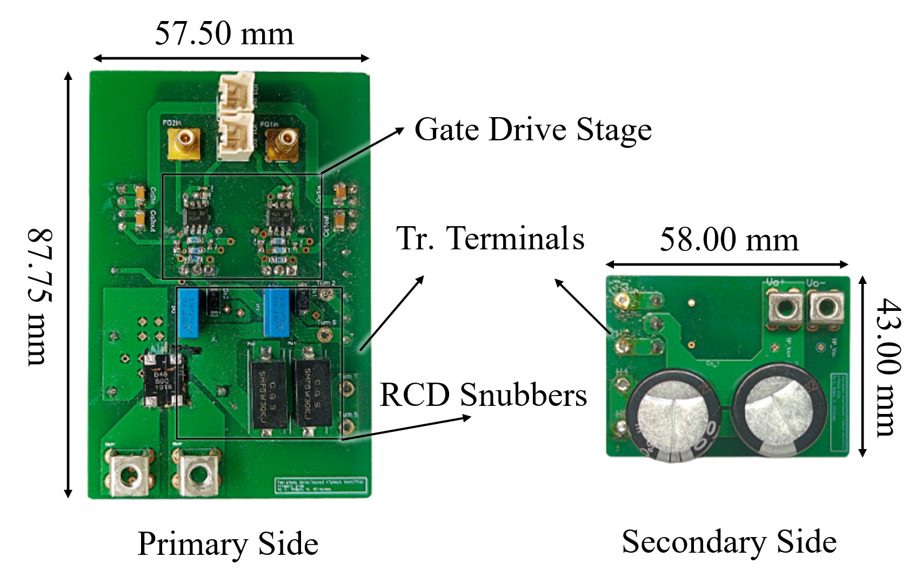  Fig. 11. Photograph of the evaluation board for the proposed integreated flyback PFC rectifier.
N/A | 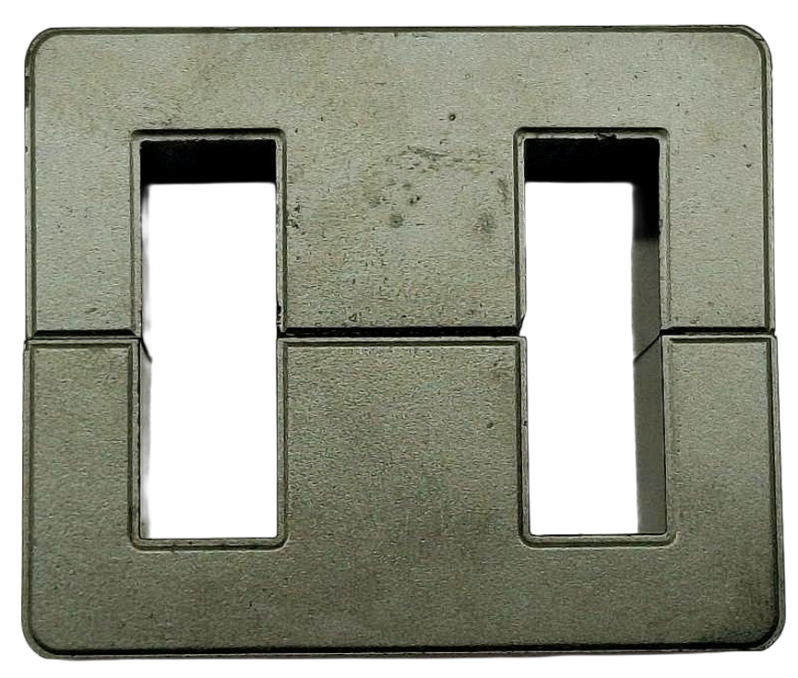  (a)  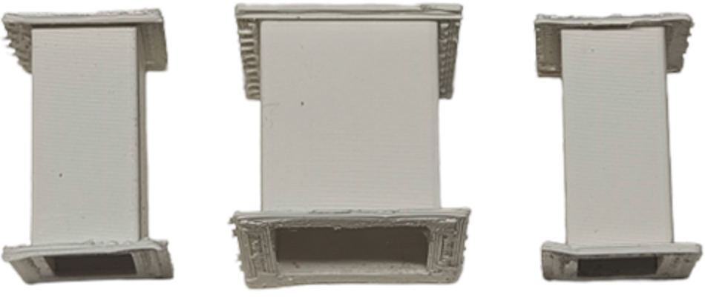  (b)  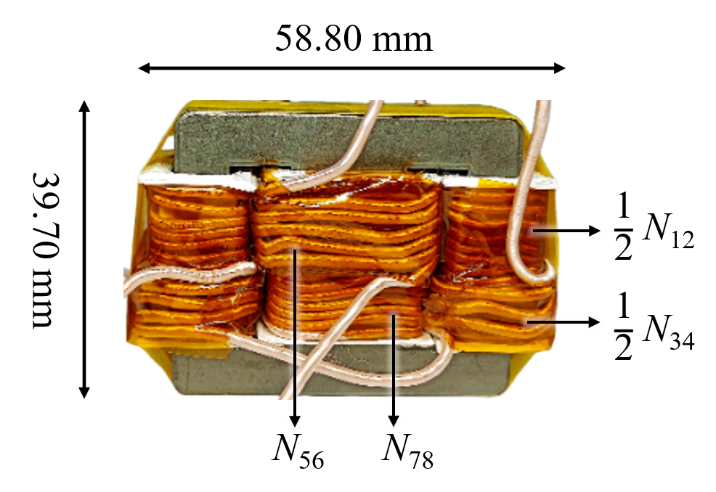  (c)  Fig. 12. Photographs of the proposed integrated transformer: (a) EE-core for the prototype; (b) lab-produced coil formers using a Flashforge Adventurer 4 Series 3D printer; and (c) final assembled prototype, with windings labeled.
N/A | 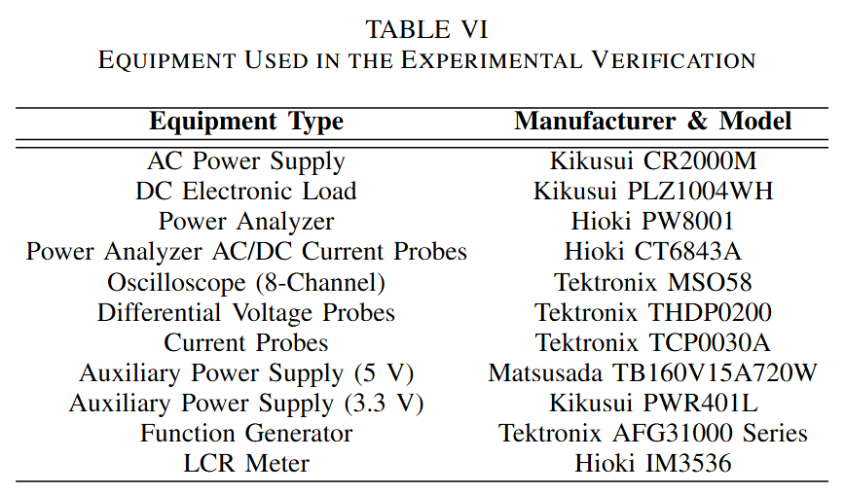

- A detailed loss breakdown should be presented, particularly for the transformer, which is the main contribution of the work. The analysis should be accompanied by a comparison with a conventional interleaved flyback implementation to highlight better the advantages and trade-offs of the proposed magnetic structure.
We thank the reviewer for this insightful comment. We thank the reviewer for this insightful comment. As explained in our response to Comment #3, because the electrical operation is decoupled and remains identical to a discrete setup, we expect that the semiconductor switching and conduction losses (from the MOSFETs and diodes) will be essentially identical to those of a conventional configuration. The efficiency differences lie entirely within the integrated transformer. For the transformer losses, extracting an exact loss breakdown (e.g. separating core and winding losses) from the physical prototype is challenging without highly specialized calorimetric measurement setups. Moreover, the physical prototype was constructed strictly as a proof-of-concept to validate the magnetic decoupling principle as an integrated transformer. Consequently, while the current prototype demonstrates stable operational performance, it has not yet undergone comprehensive core and winding optimization.

We can, however, provide a qualitative explanation of the magnetic loss mechanisms compared to a conventional discrete setup. The dimensions of the integrated transformer and discrete transformers in the ideal situation where components can be custom-made and precision is not a problem are obtained using the area products calculated in Section IV, which has been revised to reflect the latest changes in terms of depth of explanation and calculation.

Core Loss Considerations:
In a conventional discrete setup, the flux density remains uniform across isolated magnetic paths. In the proposed integrated core, the shared flux paths result in a complex flux distribution due to the superposition of individual phase contributions, as illustrated in Fig. 7. During overlapping conduction intervals, this superposition creates localized regions of high flux density (additive flux, increasing $ΔB$) in one outer leg, but conversely creates regions of reduced flux density (subtractive flux) in the other outer leg. Because ferrite core loss scales non-linearly with flux density, the net impact on the total core loss involves both positive and negative components. Determining whether the overall core loss is strictly higher or lower than a discrete setup requires extensive finite element analysis (FEA) and volumetric loss integration, which remains a subject for future analysis.

Winding Loss Considerations:
The physical geometry of the shared EE-core forces a structural asymmetry. To balance the magnetizing inductance across the shared core, the transformer on the outer legs requires an increased turn count. While the outer legs possess a smaller perimeter, which partially offsets the DC resistance penalty of the extra turns, the overall winding losses in this initial proof-of-concept are not yet fully optimized. Achieving parity or superiority in AC resistance $R_{ac}$ compared to a conventional setup will require extensive parameter sweeps and careful optimization of the winding geometry, which is a primary focus for our future work.

Therefore, we believe that the proposed structure reveals that it currently prioritizes physical miniaturization over maximum efficiency, enabling a 16% reduction in overall magnetic volume. The peak system efficiency of 84.6% demonstrates that before comprehensive magnetic optimization, the converter maintains viable and stable operation.

We revised the manuscript to provide qualitative insight into the transformer losses, as seen in the newly added Section IV-B.

Before Revision | After Revision
N/A | (after Section IV-A)  While the proposed integrated transformer achieves a theoretical 16% reduction in core volume, this structural integration introduces distinct qualitative trade-offs regarding core and winding losses.  In a conventional discrete setup, the flux density remains uniform across the isolated magnetic paths. In contrast, the proposed integrated core shares flux paths, resulting in a complex flux distribution due to the superposition of individual phase contributions. As established in the theoretical waveforms of Fig. 7, overlapping conduction intervals create localized regions of high flux density (additive flux) in one outer leg, while simultaneously creating regions of reduced flux density (subtractive flux) in the opposite outer leg. Because core loss scales non-linearly with flux density, the net impact on the total core loss involves both mitigating and compounding factors, necessitating rigorous analysis for full volumetric loss integration in future optimization stages.  Furthermore, the geometry of the shared EE-core forces a structural asymmetry in the windings. To balance the magnetizing inductance, the outer legs require an increased turn count compared to a conventional discrete transformer. Although the smaller physical perimeter of the outer legs partially offsets the DC resistance penalty of these additional turns, the high-frequency AC resistance $R_{ac}$ remains highly dependent on the physical layering and winding arrangement. Consequently, achieving optimal winding efficiency requires careful geometric optimization and parameter sweeping, which is a critical focus for the future phases of this study.

To Reviewer 2
We authors appreciate your valuable comments. The revised parts are indicated by red texts in the manuscript.
Comments to the Author
Although the paper extends the concept presented in the conference version, the explanations are presented in a vague and unclear manner, making the technical content difficult to follow and understand.

We sincerely thank the reviewer for their time and valuable feedback. We acknowledge that the initial manuscript lacked the necessary clarity in several of its technical explanations, and we appreciate you bringing this to our attention.

In response to this and your subsequent comments, we have conducted a comprehensive review and major revision of the manuscript to ensure the technical content is presented rigorously, logically, and clearly.
- What is the voltage across capacitor Cin? Please provide an analytical expression and discuss its variation under different operating conditions. Also check the presence of Cin in Fig.1©.
We thank the reviewer for pointing this out. The capacitor $C_{in}$ acts as a high-frequency filter placed immediately after the input bridge diode. Its primary role is to bypass the high-frequency switching current ripple generated by the interleaved flyback phases, preventing this switching noise from flowing back into the AC grid.

The voltage across $C_{in}$ is the rectified AC line voltage, given analytically by $v_{in}\left(t\right)=V_{in_{max}}|\sin\left(2πf_{line}t\right)|$, where $V_{in_{max}}$ represents the peak of the AC input voltage and $f_{line}$ represents the line frequency. Under variable load conditions, this voltage profile remains strictly dictated by the AC main voltage and does not change dynamically with the load.

To clarify this for readers, we have added a brief explanation regarding the function and the required voltage rating of $C_{in}$ to Section II-A of the revised manuscript. Additionally, we apologize for the omission in Fig. 1(c). We have updated Fig. 1(c) in the revised manuscript to explicitly include this input capacitor, ensuring consistency with the detailed proposed topology shown in Fig. 2(a).

Before revision | After revision
(Section II-A, 1st paragraph)  The proposed integrated transformer, shown in Fig. 2(b) was designed for a two-phase interleaved flyback PFC rectifier, shown in Fig. 2(a) operating in discontinuous conduction mode (DCM). The switches ($S_{1}$, $S_{2}$ in Fig. 2(a)) operate with a fixed duty cycle $D$ and a 180-degree phase shift. | (Section II-A, 1st paragraph)  The proposed integrated transformer, shown in Fig. 2(b) was designed for a two-phase interleaved flyback PFC rectifier, shown in Fig. 2(a) operating in discontinuous conduction mode (DCM). The switches ($S_{1}$, $S_{2}$ in Fig. 2(a)) operate with a fixed duty cycle $D$, fixed switching frequency$f_{s}$, and a 180-degree phase shift. The input capacitor $C_{in}$ acts as a high-frequency filter to bypass the switching current ripple. Because it is connected directly after the bridge diode, the voltage across $C_{in}$ inherently follows the rectified AC line voltage; therefore, its required voltage rating must be selected to safely exceed the peak AC input voltage.

Before revision | After revision
(Fig. 1)  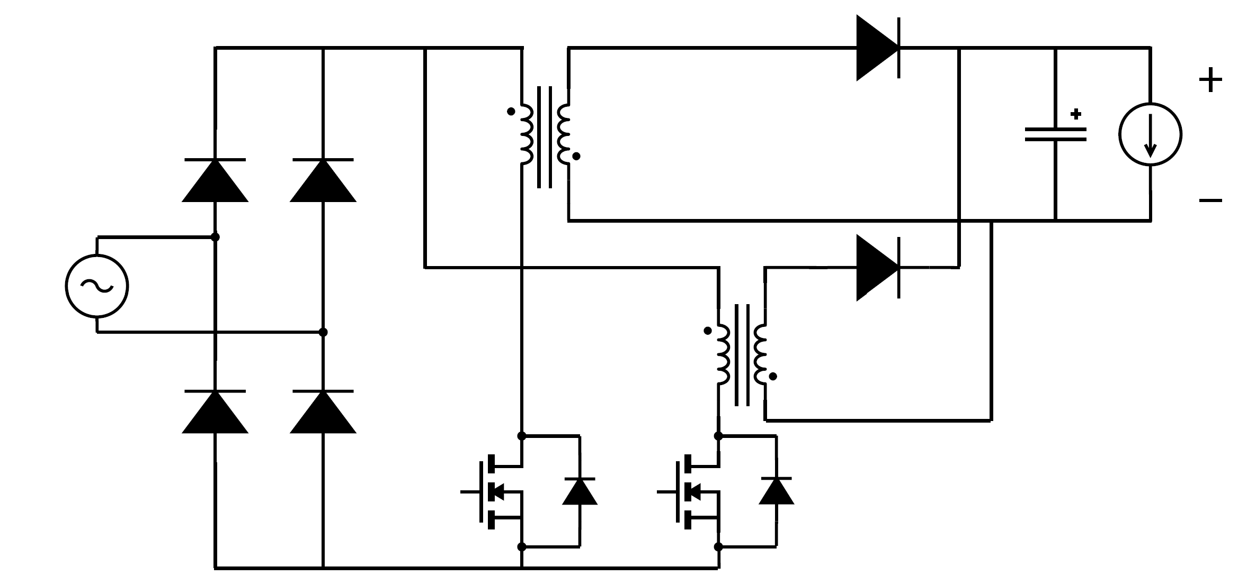  (c)  Fig. 1. Power supply configurations proposed for PD applications: (a) PFC boost, LLC, and buck converter combination in [10], [11], (b) PFC boost with AHB flyback [1], (c) two-phase interleaved flyback PFC rectifier. | (Fig. 1)  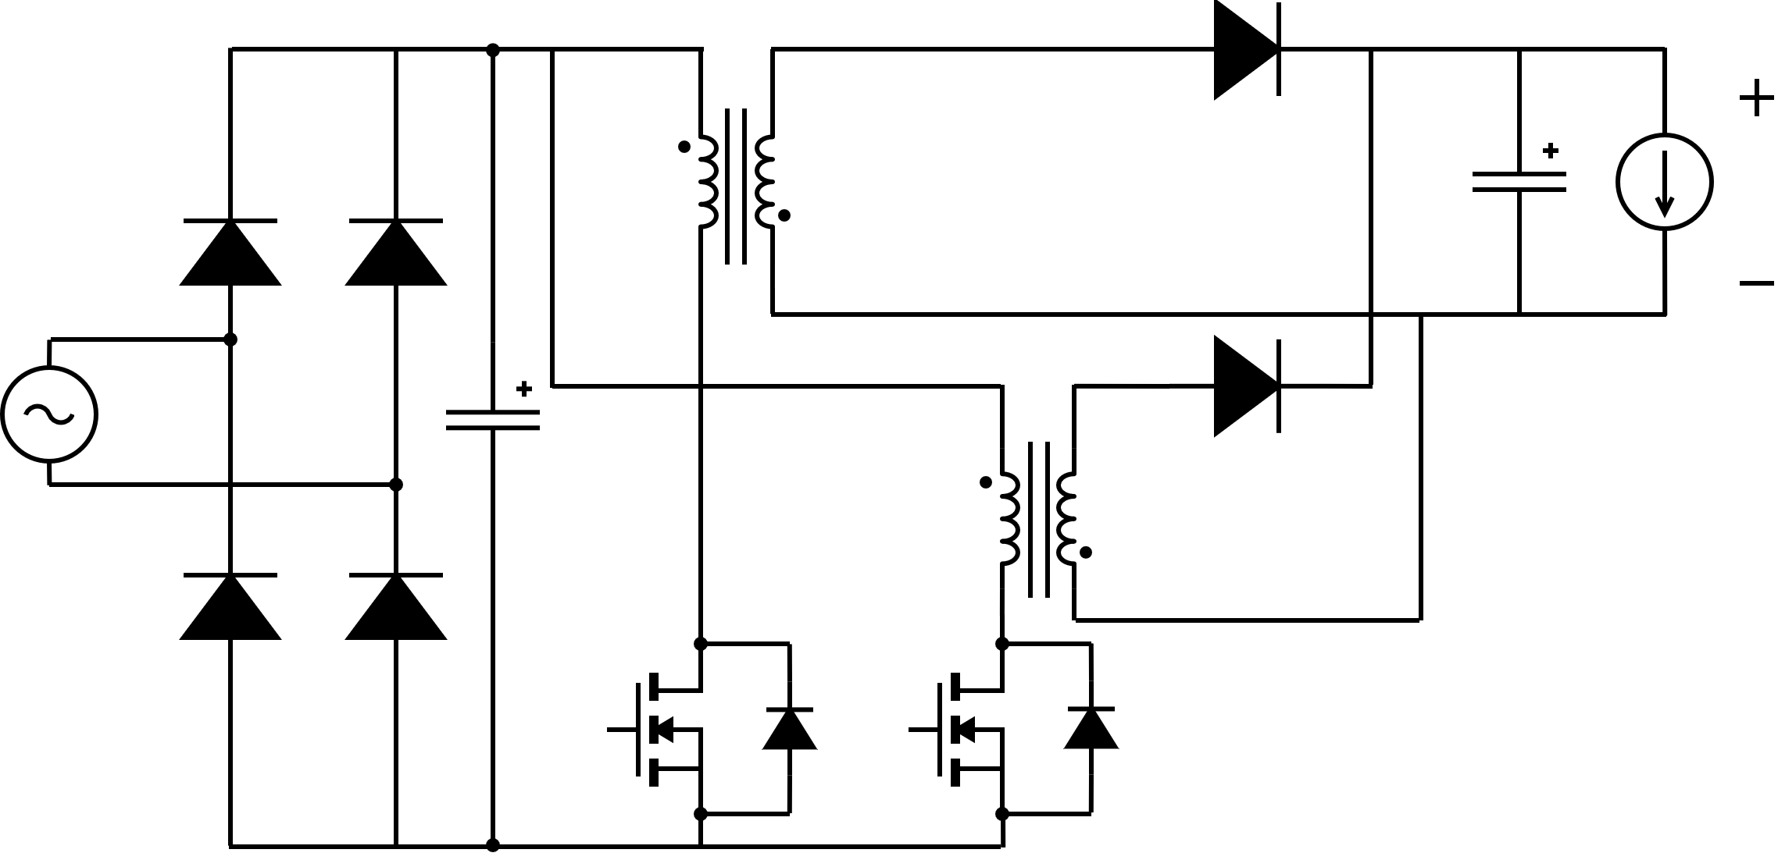  (c)  Fig. 1. Power supply configurations proposed for PD applications: (a) PFC boost, LLC, and buck converter combination in [10], [11], (b) PFC boost with AHB flyback [1], (c) two-phase interleaved flyback PFC rectifier.

- Please explain how variations in input voltage affect the magnetic flux density and switch current stresses. A detailed theoretical analysis would improve understanding.
Thank you for this insightful comment. In the previous manuscript version, the equations detailing the magnetic flux density and switch current were presented primarily as static peak values for each active phase, as shown in Eq. (2) through (5). We completely agree that because this converter operates as a PFC rectifier, discussing the time-dependent behavior provides a much clearer understanding of the transient dynamics and the exact instantaneous component stresses.

To address this, we have expanded Section II-A to explicitly show the theoretical time-domain equations. Because the instantaneous input voltage follows a rectified, sinusoidal waveform, $v_{in}\left(t\right)=V_{in_{max}}|\sin\left(2πf_{line}t\right)|$. The exact instantaneous switch currents during their respective ON-intervals in a given switching cycle $k$, where $k=0,1,2,…$, can be expressed as:

For the first phase during the ON-time of $S_{1}$ ($kT_{s}≤t≤\left(k+D\right)T_{s}$):
$$i_{S_{1}}\left(t\right)=\frac{V_{in_{max}}|\sin\left(2πf_{line}t\right)|}{L_{m_{1}}}\left(t-kT_{s}\right) \left(2\right)$$

For the second phase during the ON-time of $S_{2}$, which is shifted by 180 degrees ($\left(k+0.5\right)T_{s}≤t≤\left(k+0.5+D\right)T_{s}$):
$$i_{S_{2}}\left(t\right)=\frac{V_{in_{max}}|\sin\left(2πf_{line}t\right)|}{L_{m_{2}}}\left(t-\left(k+0.5\right)T_{s}\right) \left(3\right)$$

By substituting these instantaneous currents into the flux density derivations, the exact transient magnetic flux densities for the outer legs $B_{o_{1}}^{'}\left(t\right)$ and the center leg $B_{c}^{''}\left(t\right)$ during their active intervals are:
$$B_{o}^{'}\left(t\right)=\frac{L_{m_{1}}i_{S_{1}}\left(t\right)}{N_{12}A_{o}} \left(4\right)$$

$$B_{o}^{''}\left(t\right)=B_{c}^{''}\left(t\right)=\frac{L_{m_{2}}i_{S_{2}}\left(t\right)}{N_{56}A_{c}} (5)$$
This theoretical analysis clearly demonstrates how the high-frequency switching ramps are continuously bounded by the rectified line cycle. Consequently, both the switch current and the core flux density vary dynamically, reaching their maximum values exactly at the peak of the AC line voltage, $V_{in_{max}}$.

Equations (2) to (5) in the manuscript have been revised to reflect these changes. We note that we examine the peak values of the switch current and flux density in the theoretical analysis provided in the manuscript, in a quasi-static switching event. We have added a dedicated paragraph detailing these exact operational dynamics, along with these expanded equations, to better clarify the transient behavior and component stress limits in the revised manuscript.

Before revision | After revision
(in Section II-A, at the operational mode analysis)  ….  The detailed analysis of each operating mode is as follows:  ….  2) Mode 2 ($t_{2}<t<t_{3}$, Fig. 3(b)): Mode 2 starts right after transformer $N_{56}-N_{78}$ completes its discharging phase, which means its associated currents $i_{D_{2}}$, $i_{L_{m_{2}}}$, and flux densities $B_{o_{1}}^{''}$, $B_{o_{2}}^{''}$, and $B_{c}^{''}$ are zero. Now, with $S_{1}$ still on, transformer $N_{12}-N_{34}$ continues storing energy until $i_{L_{m_{1}}}$ reaches its peak value at $t_{3}$. The peak primary current in the positive cycle $i_{S_{1_{pk}}}$ is given by (2):  $$i_{S_{1_{pk}}}=\frac{V_{in}⋅DT_{s}}{L_{m_{1}}}$$  where $V_{in}$ is the input voltage, $D$ is the duty cycle, $T_{s}$ is the switching period, and $L_{m_{1}}$ is the magnetizing inductance of transformer $N_{12}-N_{34}$. Consequently, the flux densities $B_{o_{1}}^{'}$ and $B_{o_{2}}^{'}$ also reach their peak values $B_{o_{pk}}^{'}$ which are given by (3):  $$B_{o_{pk}}^{'}=\frac{L_{m_{1}}i_{S_{1_{pk}}}}{N_{12}A_{o}}$$  with $N_{12}$ as the number of turns in the primary side of the active transformer and $A_{o}$ is the cross-sectional area of the outer leg, where the transformer $N_{12}-N_{34}$ is wound. | (in Section II-A, at the operational mode analysis)  ….  The detailed analysis of each operating mode is as follows:  ….  2) Mode 2 ($t_{2}<t<t_{3}$, Fig. 3(b)): Mode 2 starts right after transformer $N_{56}-N_{78}$ completes its discharging phase, which means its associated currents $i_{D_{2}}$, $i_{L_{m_{2}}}$, and flux densities $B_{o_{1}}^{''}$, $B_{o_{2}}^{''}$, and $B_{c}^{''}$ are zero. Now, with $S_{1}$ still on, transformer $N_{12}-N_{34}$ continues storing energy until $i_{L_{m_{1}}}$ reaches its peak value at $t_{3}$.  Because the converter operates as a PFC rectifier, the instantaneous input voltage follows a rectified sinusoidal envelope $v_{in}\left(t\right)=V_{in_{max}}|\sin\left(2πf_{line}t\right)|$, where $V_{in_{max}}$ is the peak AC line voltage and $f_{line}$ is the line frequency. Assuming $v_{in}\left(t\right)$ is quasi-static during a single high-frequency switching cycle, the time-variant peak primary current $i_{S_{1_{pk}}}\left(t\right)$ reached at the end of the ON-time of the first active phase is given by:  $$i_{S_{1_{pk}}}\left(t\right)=\frac{V_{in_{max}}|\sin\left(2πf_{line}t\right)|}{L_{m_{1}}}DT_{s} \left(2\right)$$  where $D$ is the duty cycle, $T_{s}$ is the switching period, and $L_{m_{1}}$ is the magnetizing inductance of transformer $N_{12}-N_{34}$. Consequently, the flux densities $B_{o_{1}}^{'}$ and $B_{o_{2}}^{'}$ also reach their cycle-specific peak values $B_{o_{pk}}^{'}\left(t\right)$ which are given by (3):  $$B_{o_{pk}}^{'}\left(t\right)=\frac{L_{m_{1}}i_{S_{1_{pk}}}\left(t\right)}{N_{12}A_{o}} \left(3\right)$$  with $N_{12}$ as the number of turns in the primary side of the active transformer and $A_{o}$ is the cross-sectional area of the outer leg, where the transformer $N_{12}-N_{34}$ is wound.
(in Section II-A, at the operational mode analysis)  ….  The detailed analysis of each operating mode is as follows:  ….  5) Mode 5 ($t_{5}<t<t_{6}$, Fig. 3(e)): Mode 5 starts after the discharge of transformer $N_{12}-N_{34}$ completes. Now, with Switch $S_{2}$ still on, transformer $N_{56}-N_{78}$ continues storing energy until $i_{L_{m_{2}}}$ reaches its peak value at $t_{6}$. The peak primary current in the negative cycle $i_{S_{2_{pk}}}$ is given by (4):  $$i_{S_{2_{pk}}}=\frac{V_{in}⋅DT_{s}}{L_{m_{2}}}$$  where $L_{m_{2}}$ is the magnetizing inductance of transformer $N_{56}-N_{78}$. Consequently, the flux densities $B_{o_{1}}^{''}$, $B_{c}^{''}$ and $B_{o_{2}}^{''}$ also reach their peak values. The peak value of $B_{c_{pk}}^{''}$ is given by (5):  $$B_{c_{pk}}^{''}=B_{o_{pk}}^{''}\left(t\right)=\frac{L_{m_{2}}i_{S_{2_{pk}}}}{N_{56}A_{c}}$$  with $N_{56}$ as the number of turns in the primary side of the active transformer and $A_{c}$ is the cross-sectional area of the center leg where the transformer $N_{56}-N_{78}$ is wound. | (in Section II-A, at the operational mode analysis)  ….  The detailed analysis of each operating mode is as follows:  ….  5) Mode 5 ($t_{5}<t<t_{6}$, Fig. 3(e)): Mode 5 starts after the discharge of transformer $N_{12}-N_{34}$ completes. Now, with Switch $S_{2}$ still on, transformer $N_{56}-N_{78}$ continues storing energy until $i_{L_{m_{2}}}$ reaches its peak value at $t_{6}$. Similarly bounded by the input voltage envelope, the time-variant peak primary current $i_{S_{2_{pk}}}\left(t\right)$ reached at the end of the ON-time of the second active phase is given by:  $$i_{S_{2_{pk}}}\left(t\right)=\frac{V_{in_{max}}|\sin\left(2πf_{line}t\right)|}{L_{m_{2}}}DT_{s} \left(4\right)$$  where $L_{m_{2}}$ is the magnetizing inductance of transformer $N_{56}-N_{78}$. Consequently, the flux densities $B_{o_{1}}^{''}$, $B_{c}^{''}$ and $B_{o_{2}}^{''}$ also reach their cycle-specific peak values. The time-variant peak value of the center leg flux density $B_{c_{pk}}^{''}\left(t\right)$ is given by (5):  $$B_{c_{pk}}^{''}\left(t\right)=B_{o_{pk}}^{''}\left(t\right)=\frac{L_{m_{2}}i_{S_{2_{pk}}}\left(t\right)}{N_{56}A_{c}} \left(5\right)$$  with $N_{56}$ as the number of turns in the primary side of the active transformer and $A_{c}$ is the cross-sectional area of the center leg where the transformer $N_{56}-N_{78}$ is wound.
N/A | (in Section II-A, inserted before the last paragraph)  As derived in the expanded time-variant equations for Mode 2 and Mode 5, the linear switching ramps are continuously bounded by the low-frequency cycle of $v_{in}$. Consequently, both the instantaneous switch current stress and the peak core flux density vary dynamically across the line period. The converter components experience their absolute maximum operational stresses exclusively at the peak of the AC line voltage $V_{in_{max}}.$

- The duty cycle is not adequately defined in the manuscript.
Thank you for this valuable feedback. We agree that the definition of the duty cycle $D$ and its relationship to the discharge time $t_{dis}$, as given in Eq. (1), required further clarification.

First, we have revised the text to explicitly state that the proposed circuit relies on the exact same operating principles as a conventional two-phase interleaved flyback rectifier. The integration of the transformer does not alter the fundamental switching sequence or the definition of the duty cycle.

Because the converter must operate in Discontinuous Conduction Mode (DCM), the duty cycle $D$ strictly determines the ON-time of the switches. Consequently, it dictates how fast the stored energy in the magnetizing inductance discharges. As shown in Eq. (1), the discharge time $t_{dis}$ is simply the required interval for the magnetizing current of one phase to return to zero before the subsequent phase reaches its peak. We have updated Section II-A to make this operational equivalency and the boundaries of $D$ much clearer to the reader.

Furthermore, regarding the open-loop control scheme utilized in this study, the operating duty cycle is mathematically defined by the physical circuit specifications. We explicitly referenced Equation (28) in the manuscript, which defines $D$ as a function of the required output power $P_{o}$, switching period $T_{s}$, peak input voltage $V_{in_{max}}$, and magnetizing inductance $L_{m}$. This definition is completely consistent with standard conventional flyback design principles.

Before revision | After revision
(in Section II-A, 3rd paragraph)  The operational principle of the rectifier with the proposed transformer is illustrated in Fig. 3. Additionally, Fig. 4 presents the key waveforms of the six distinct operation modes. The rectifier is designed with duty cycle $D≤0.5\frac{nV_{o}}{V_{in_{max}}}$ with $n$ as the turns ratio, $V_{o}$ as the output voltage, and $V_{in_{max}}$ as the peak value of the input voltage. … | (in Section II-A, 3rd paragraph)  The operational principle of the rectifier with the proposed transformer is illustrated in Fig. 3. Additionally, Fig. 4 presents the key waveforms of the six distinct operation modes. It is important to note that despite the integrated magnetic structure, the rectifiers in each interleaved phase operate on the exact same principle as a conventional DCM flyback converter. The rectifier is designed with a strictly limited duty cycle $D≤0.5\frac{nV_{o}}{V_{in_{max}}}$ with $n$ as the turns ratio, $V_{o}$ as the output voltage, and $V_{in_{max}}$ as the peak value of the input voltage. …

- How is power factor correction (PFC) achieved or ensured in the proposed converter? Please provide supporting analysis and experimental verification. The PFC control methodology is not clearly described.
Thank you for your valuable comment. The proposed two-phase interleaved flyback rectifier is designed to operate in Discontinuous Conduction Mode (DCM). A fundamental characteristic of a DCM flyback topology is that it naturally achieves power factor correction (PFC) without requiring a complex, active current-shaping control loop.

When the converter operates with a fixed switching frequency and a constant duty cycle $D$ across the AC line half-cycle, the peak and average currents drawn by each transformer phase during a switching period are directly proportional to the instantaneous rectified input voltage. Because there is no phase shift between the voltage and the drawn current, the total average input current inherently tracks the sinusoidal envelope of the AC input voltage, yielding a high-power factor under open-loop control.

The mathematical derivation confirming this inherent PFC behavior for the two-phase interleaved structure is detailed below:

Given a fixed switching frequency $f_{s}$ over the switching period $T_{s}$ and a constant duty cycle D across the AC line half-cycle, the peak current of the main switch for the first phase, $i_{S1_{pk}}\left(t\right)$, is determined by the instantaneous input voltage and is expressed as:
$$i_{S1_{pk}}\left(t\right)=\frac{v_{in}\left(t\right)DT_{s}}{L_{m}}$$
where $v_{in}\left(t\right)$ is the instantaneous rectified input voltage and $L_{m}$ is the magnetizing inductance of the active transformer phase.

The average input current drawn by the first phase over one switching period is calculated by integrating the triangular switch current waveform:

$$\left\langle i_{S1}\right\rangle \left(t\right)=\frac{1}{T_{s}}\int_{0}^{T_{s}}{i_{S1}}\left(τ\right)dτ=\frac{1}{T_{s}}\left(\frac{1}{2}i_{S1_{pk}}\left(t\right)DT_{s}\right)=\frac{v_{in}\left(t\right)D^{2}T_{s}}{2L_{m}}$$

Because the proposed converter utilizes a two-phase interleaved structure, the second phase operates identically to the first, shifted by 180 degrees. A symmetrical design is utilized in this flyback converter, where both phases share the same $L_{m}$, the average current drawn by the second phase is identical:

$$\left\langle i_{S2}\right\rangle \left(t\right)=\frac{v_{in}\left(t\right)D^{2}T_{s}}{2L_{m}}$$

The total average input current, $\left\langle i_{in}\right\rangle \left(t\right)$, drawn from the rectified input voltage is the sum of the average currents of both active phases:
$$\left\langle i_{in}\right\rangle \left(t\right)=\left\langle i_{S1}\right\rangle \left(t\right)+\left\langle i_{S2}\right\rangle \left(t\right)=\frac{v_{in}\left(t\right)D^{2}T_{s}}{L_{m}}$$
Since $D$, $T_{s}$, and $L_{m}$ are all constant values during steady-state open-loop operation, the total average input current is directly proportional to the instantaneous rectified input voltage:

$$\left\langle i_{in}\right\rangle \left(t\right)∝v_{in}\left(t\right)$$

Because $v_{in}\left(t\right)$ follows a rectified sinusoidal voltage $V_{in_{max}}|\sin\left(2πf_{line}t\right)|$), the input current inherently tracks the sinusoidal shape of the AC main voltage. Consequently, the converter naturally achieves PFC in DCM without requiring a dedicated active current-shaping control loop. This is seen in the experimental waveform in Fig. 15(a), where we could see from the macroscopic view that $i_{S1}$ and $i_{S2}$ are in-phase with the AC input voltage $v_{in}$.

We added an appendix detailing the calculation shown above. We expanded the discussion on this matter in Section II-A of the manuscript as follows.

Before Revision | After Revision
N/A | (after the last paragraph of Section II-A)  Because the proposed integrated transformer achieves magnetic decoupling, the fundamental DCM operation of the converter remains electrically identical to a conventional interleaved topology utilizing discrete transformers. As a result, the standard electrical benefits of two-phase interleaving are fully preserved. Utilizing the same fixed $f_{s}$, $D$, and $L_{m}$, the phase currents are governed by identical electrical principles, ensuring that input and output current ripple cancellation is maintained. PFC and Total Harmonic Distortion (THD) are expected to be similar performance expected from a conventional discrete setup.

- The experimental results are not sufficiently clear for readers to fully understand the converter operation. Consider improving waveform quality and adding more detailed explanations.
Thank you for your comments. We agree that the experimental waveforms needed improvement. We have revised the figures to have clearer traces by thinning the grid lines and making the colored traces more saturated. We also remove the cluttered annotations. The revised text for the explanation of the waveforms in Section V (Fig. 15) will be shown in the next comment, which also asks for a detailed explanation of the observed phenomena in the waveforms.
Before revision | After revision
(in Section V, Fig. 15)  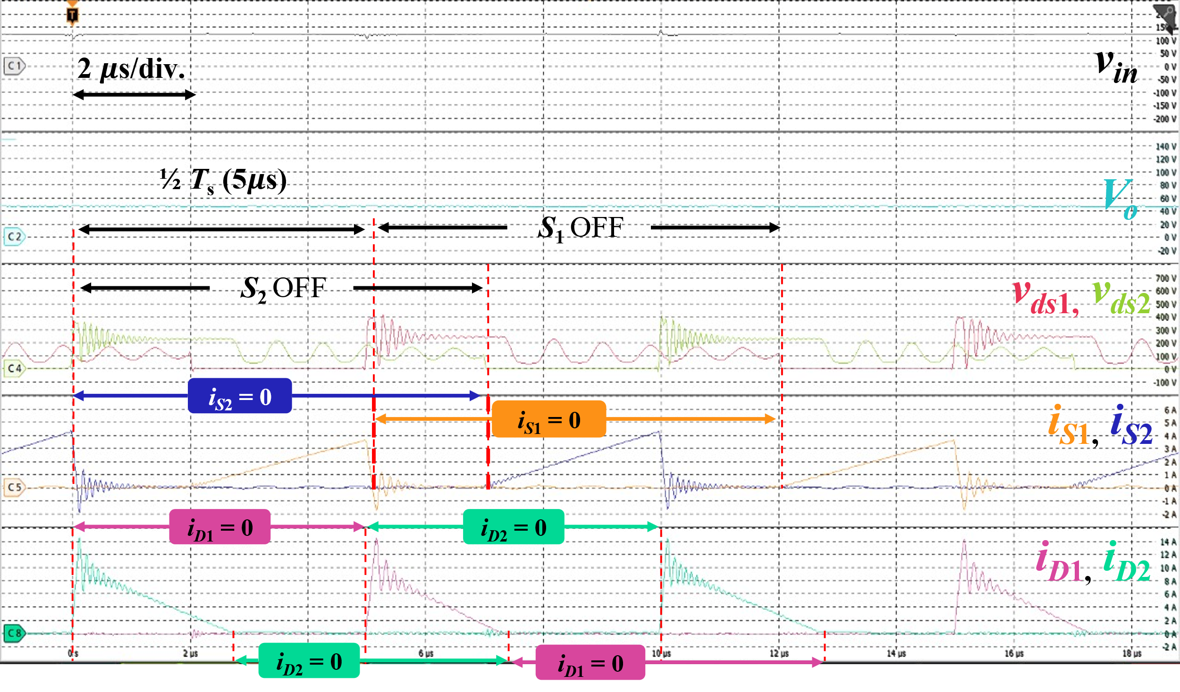  (b)  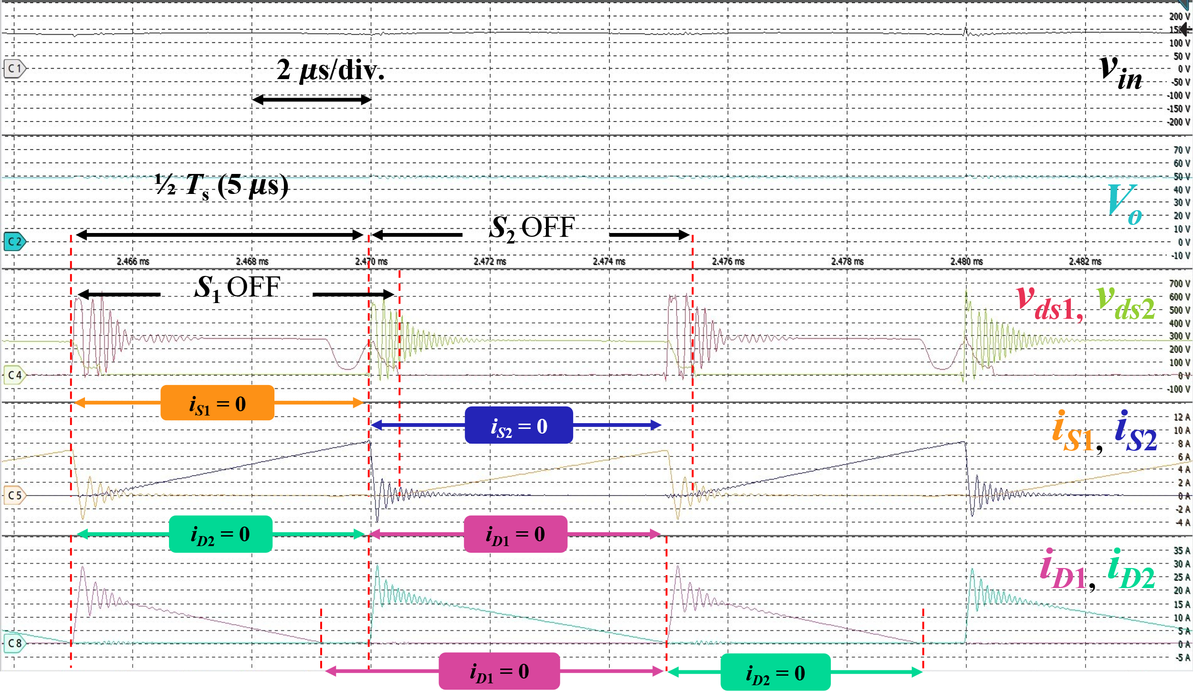  (c)  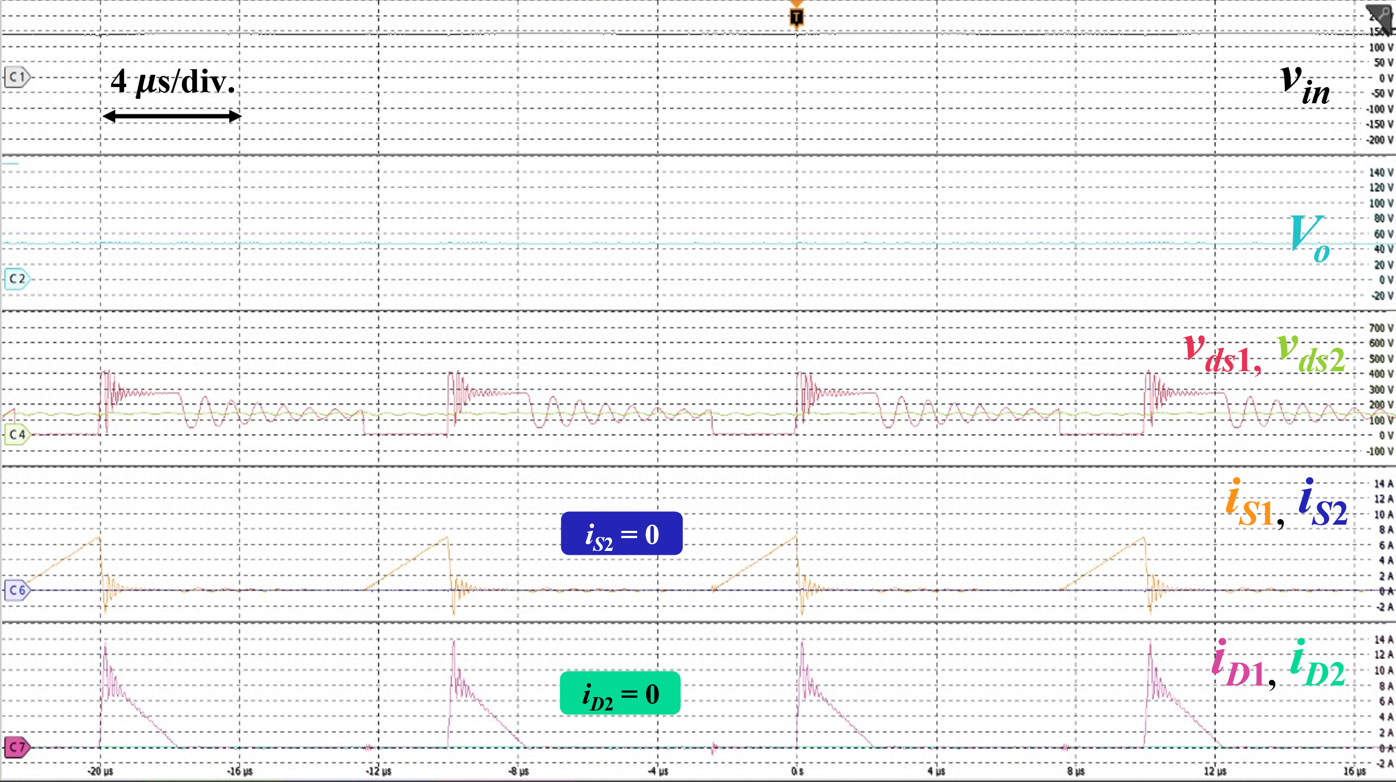  (d)  Fig. 15. Experimental waveforms of a two-phase interleaved flyback rectifier with the proposed integrated transformer at (a) and (b): 100 W, two-phase AC drive; (c): 240 W, two-phase AC drive; (d): 32.5 W, single-phase AC drive. For (a) and (b): $v_{in}$: 50 V/div., $V_{o}$: 10 V/div., $v_{ds1}$, $v_{ds2}$: 100 V/div., $i_{S1}$, $i_{S2}$: 1 A/div., $i_{D1}$, $i_{D2}$: 5 A/div.; For (c): $v_{in}$: 50 V/div., $V_{o}$: 10 V/div., $v_{ds1}$, $v_{ds2}$: 100 V/div., $i_{S1}$, $i_{S2}$: 2 A/div., $i_{D1}$, $i_{D2}$: 5 A/div.; For (d): $v_{in}$: 50 V/div., $V_{o}$: 20 V/div., $v_{ds1}$, $v_{ds2}$: 100 V/div., $i_{S1}$, $i_{S2}$: 2 A/div., $i_{D1}$, $i_{D2}$: 2 A/div. | (in Section V, Fig. 15)  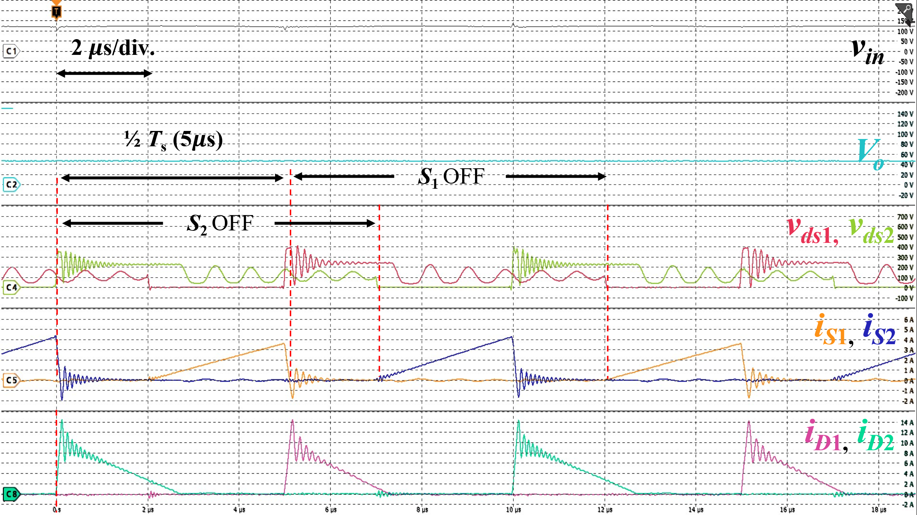  (b)  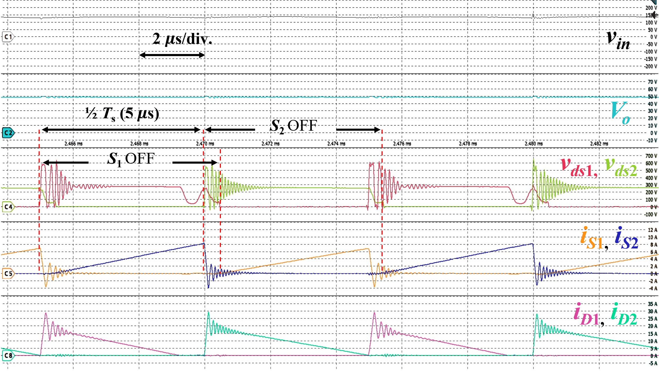  (c)  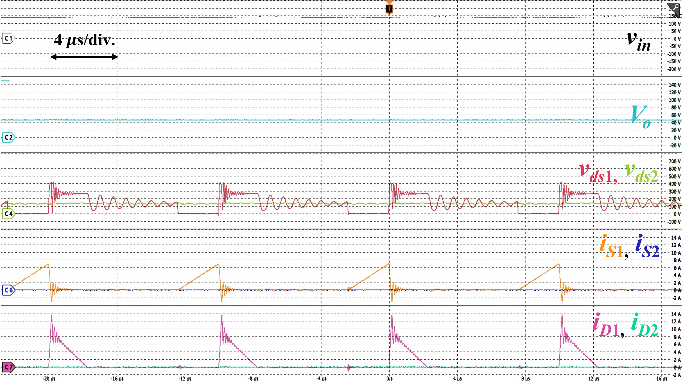  (d)  Fig. 15. Experimental waveforms of a two-phase interleaved flyback rectifier with the proposed integrated transformer at (a) and (b): 100 W, two-phase AC drive; (c): 240 W, two-phase AC drive; (d): 32.5 W, single-phase AC drive. For (a) and (b): $v_{in}$: 50 V/div., $V_{o}$: 10 V/div., $v_{ds1}$, $v_{ds2}$: 100 V/div., $i_{S1}$, $i_{S2}$: 1 A/div., $i_{D1}$, $i_{D2}$: 5 A/div.; For (c): $v_{in}$: 50 V/div., $V_{o}$: 10 V/div., $v_{ds1}$, $v_{ds2}$: 100 V/div., $i_{S1}$, $i_{S2}$: 2 A/div., $i_{D1}$, $i_{D2}$: 5 A/div.; For (d): $v_{in}$: 50 V/div., $V_{o}$: 20 V/div., $v_{ds1}$, $v_{ds2}$: 100 V/div., $i_{S1}$, $i_{S2}$: 2 A/div., $i_{D1}$, $i_{D2}$: 2 A/div.

- Significant ringing is observed during the switching transitions of S1 and S2. Please explain the cause of this oscillation and discuss possible mitigation methods.
- A persistent oscillation is visible in the Vds1 waveform. Please provide a detailed explanation of its origin and impact on converter performance.
We thank the reviewer for these insightful comments. We address questions 6 and 7 together, as both pertain to parasitic resonant behaviors observed in the v_{ds} waveforms, though they are driven by two distinct mechanisms, as described in reference [26]. A sample waveform, shown in Fig. 15(b), is referenced in this discussion and is also placed below for easy reference. The annotations are removed as well for easier understanding.
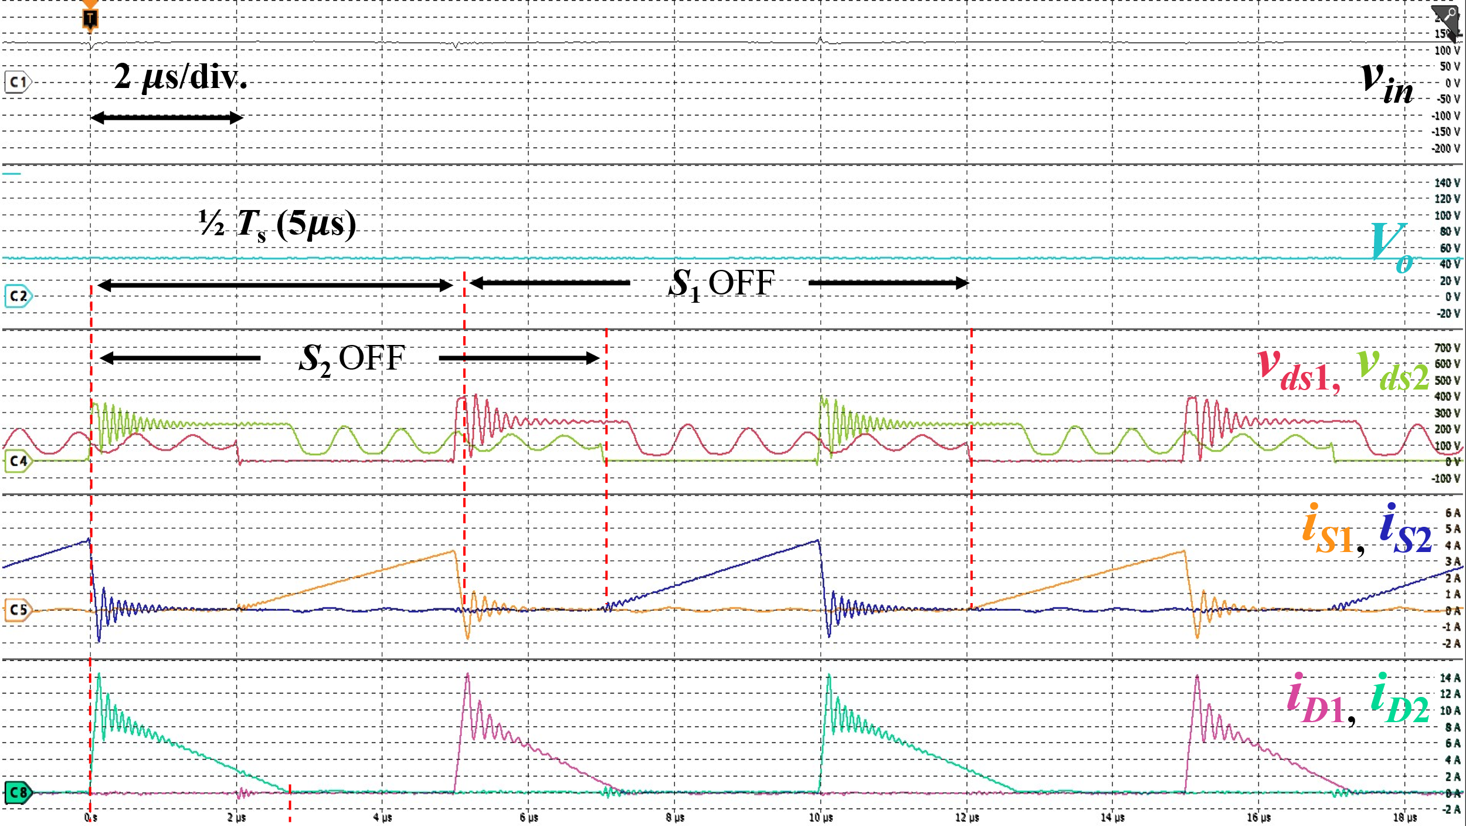
Oscillations in the Switching Transitions of S₁ and S₂
The significant, high-frequency ringing observed during the switching transitions of $S_{1}$ and $S_{2}$ occurs immediately at switch turn-off. This is caused by the resonance between the leakage inductance of the transformer $L_{lk}$ and the parasitic output capacitance of the switches $C_{oss}$. This phenomenon occurs regardless of the conduction mode. To mitigate this voltage stress and absorb the leakage energy, RCD snubbers ($C_{sn}$, $R_{sn}$, $D_{sn}$) are implemented across the primary windings, as denoted in Fig. 10(a).
Oscillations in v_{ds1} (and v_{ds2})
The persistent, lower-frequency oscillation visible in the $v_{ds1}$ and $v_{ds2}$ waveforms occurs during the discontinuous interval. Specifically, this begins when the secondary diode currents $i_{D1}$ and $i_{D2}$ drop to zero, signifying that the transformer has fully demagnetized. At this point, the magnetizing inductance $L_{m}$ begins to resonate with $C_{oss}$, causing the oscillation persists until the next switching cycle initiates.

We fully agree with the reviewer that these resonant phenomena can introduce additional switching losses and potential reliability concerns if not properly mitigated. For this experimental prototype, we implemented a standard RCD snubber. While this basic snubber successfully dampens the transients enough to safely operate the converter and validate our proposed magnetic topology, we acknowledge that it is not the most optimal solution for maximizing overall efficiency.

However, deploying more complex mitigation strategies, such as active-clamping or advanced soft-switching techniques, falls outside the primary scope of this manuscript, which focuses strictly on proving the feasibility, volumetric reduction, and structural magnetic decoupling of the integrated transformer. Therefore, we deliberately utilized a standard RCD snubber to isolate and evaluate the performance of the magnetic structure itself, without the added complexity of advanced switching control.

To ensure these phenomena are explicitly clear to readers, we have thoroughly revised Section V-B of the manuscript to detail these two distinct resonant mechanisms.

Before revision | After revision
N/A | (in Section V-B, after the 2nd paragraph)  Two distinct parasitic resonant behaviors can be observed in the $v_{ds}$ waveforms in Fig. 15(b) and Fig. 15(c) according to the operational dynamics of the flyback converter. The same phenomenon can also be observed in Fig. 15(d) for one-phase drive. A high-frequency ringing occurs immediately at switch turn-off, driven by the resonance between the leakage inductance of the transformer and the parasitic output capacitance $C_{oss}$ of the switches. This voltage stress is mitigated by the implemented primary-side RCD snubbers. Second, a lower-frequency oscillation appears when the secondary diode currents $i_{D1}$ and $i_{D2}$ reach zero, indicating complete transformer demagnetization. During this interval, the main magnetizing inductance of the active transformer resonates with $C_{oss}$ until the next switching cycle initiates. Nevertheless, these parasitic behaviors do not interfere with the non-coupled operation of the proposed transformer.

- A photograph of the hardware prototype would be helpful. Furthermore, if a comparison with existing solutions is claimed, the corresponding experimental setup and hardware implementation should be clearly presented.
We thank the reviewer for this valuable suggestion. To provide a clearer perspective on the practical implementation, overall footprint, and power density of the proposed converter, we have added a photograph of the evaluation board to the revised manuscript (Fig. 11). As shown in the figure, the primary and secondary side boards of the converter were separated to facilitate simpler connection to the transformer and also experimental verification as there were many probes to be used. The assembly process for the integrated transformer is shown in Fig. 12. Fig. 12(a) shows the actual transformer winding implementation. When winding this transformer, the thicker secondary windings are placed directly on top of the thinner primary windings. This overlapping arrangement minimizes the unused space within the window area and tightly couples the layers, effectively reducing the leakage inductance. The windings are wound around the coil formers first as shown in Fig. 12(b), which were created through the use of a 3D printer, and are finally placed on the EE-core as shown in Fig. 12(c).

Furthermore, to fully clarify the experimental setup, we have explicitly detailed the precision measurement equipment, including the specific power supplies, power analyzer, oscilloscope, and probes utilized, in Section V-A of the revised manuscript.

Before revision | After revision
(Section V-A, 1st paragraph)  A prototype two-phase interleaved flyback rectifier, shown in Fig. 10(a) operating in DCM, was built to verify the operation of the integrated transformer. The prototype integrated transformer, shown in Fig. 10(b), was also designed using the proposed method. The specifications of the two-phase interleaved flyback rectifier and transformer are shown in Tables IV and V, respectively. The transformer parameters were characterized using a Hioki IM3536 LCR meter at 100 kHz. The coupling coefficients of the transformers $k_{N12-N34}$, $k_{N56-N78}$, and $k_{N12-N56}$ were derived from the mutual inductance obtained after connecting the respective transformer windings in series-aiding and series-opposing configurations. The coupling coefficient between the two flyback transformers $k_{N12-N56}$ is 0.0005, showing that the coupling was almost eliminated. | (Section V-A, 1st paragraph to 3rd paragraph)  A prototype two-phase interleaved flyback rectifier, with the circuit schematic shown in Fig. 10(a), was built to verify the operation of the integrated transformer operating in DCM. A photograph of the prototype evaluation board is provided in Fig. 11(a), with the primary and secondary side separated for simple implementation. Because the fundamental operating principles of the converter remain identical to a conventional discrete setup, standard closed-loop modulation methods are directly applicable. Therefore, the experimental evaluation was intentionally conducted using open-loop control with a fixed duty cycle decided using (28).  The prototype integrated transformer, represented in Fig. 10(b), was also designed using the proposed method. To strictly minimize leakage inductance, the primary and secondary windings of the transformer for each respective phase were physically overlapped on their designated legs. The EE-core used for the prototype is shown in Fig. 12(a). The windings are wound around lab-made coil formers, as shown in Fig. 12(b), which were fabricated using a Flashforge Adventurer 4 Series 3D printer, and are finally placed onto the corresponding legs of the core. A photograph of the fully assembled prototype integrated transformer is shown in Fig. 12(c). The specifications of the two-phase interleaved flyback rectifier and transformer are shown in Tables IV and V, respectively.  The comprehensive list of equipment used in the experimental evaluation is summarized in Table VI. Key data was recorded using a Hioki PW8001 power analyzer for system efficiency and power measurements, alongside a Tektronix MSO58 high-definition oscilloscope to capture experimental waveforms. The open-loop PWM signals were generated via a Tektronix AFG31000 Series function generator, and the integrated transformer parameters were characterized using a Hioki IM3536 LCR meter at 100 kHz.  The coupling coefficients of the transformers $k_{N12-N34}$, $k_{N56-N78}$, and $k_{N12-N56}$ were derived from the mutual inductance obtained after connecting the respective transformer windings in series-aiding and series-opposing configurations. The physical overlapping of the windings resulted in high intra-phase coupling coefficients, with $k_{N12-N34}$ measured at 0.970 and $k_{N56-N78}$ at 0.979. Furthermore, the cross-coupling coefficient between the two flyback transformers $k_{N12-N56}$ is 0.0005, showing that the coupling between phases was almost eliminated. Because this decoupling is geometrically enforced by the core and winding arrangement, it is expected to be maintained even under load transient conditions. While severe transients may introduce high-frequency harmonics that slightly degrade this ideal isolation due to parasitic elements, their magnitude and energy are negligible compared to the fundamental operating frequencies, ensuring that the overall dynamic stability of the converter is preserved.

Before revision | After revision
N/A | Fig. 11. Photograph of the evaluation board for the proposed integreated flyback PFC rectifier.
N/A | (a)  (b)  (c)  Fig. 12. Photographs of the proposed integrated transformer: (a) EE-core for the prototype; (b) lab-produced coil formers using a Flashforge Adventurer 4 Series 3D printer; and (c) final assembled prototype, with windings labeled.
N/A

- The manuscript should include a comprehensive comparison with relevant published literature to clearly demonstrate the advantages and unique contributions of the proposed approach.
Thank you for this valuable feedback. We completely agree that a direct, side-by-side comparison is necessary to clearly define the research gap and emphasize the distinct merits of our topology.

To address this, we have added a comprehensive comparative analysis in Section [X.X], supported by a newly introduced summary table (Table XX). This table benchmarks our proposed non-coupled integrated transformer against both conventional discrete magnetic solutions and recently published methods.
Specifically, the expanded text and Table XX explicitly highlight the dual advantages of our approach:
- Core Volume Reduction: Demonstrating the physical miniaturization achieved compared to discrete implementations.
- Decoupled Transient Operation: Highlighting how our non-coupled integration uniquely achieves decoupled interleaved operation, avoiding the transient interference and cross-regulation issues often found in conventional integrated methods.
- Simpler Implementation: Decoupling can be implemented through a winding configuration with a simple EE-core.
We believe this direct comparison strictly quantifies our contributions and provides readers with a clear understanding of the proposed structure's advantages.

- The explanation of the flux cancellation phenomenon is insufficient. Please provide a more rigorous theoretical analysis and supporting evidence. It would be beneficial to illustrate the magnetic flux path during each operating mode, all six modes as explained for working. Such diagrams would significantly improve clarity and reader understanding. (Why the flux in central limb is zero during mode1-3? It may zero for N12,34. Will there any flux present because of N56,78?)
We sincerely thank the reviewer for this excellent suggestion and sharp observation. The reviewer is entirely correct: while the flux component generated by $N_{12}-N_{34}$ in the central limb is mathematically zero, flux from $N_{56}-N_{78}$ is indeed present depending on the operating mode due to the discharging phase of the converter.
To rigorously clarify this and significantly improve reader understanding, we have replaced the original flux diagrams with a new, detailed 4-panel figure (Fig. 6 in the revised manuscript) that explicitly maps the magnetic flux paths across all six operating modes.
This new diagram directly addresses the reviewer's question regarding the center leg:
- During Mode 1 (Fig. 6(a)) and Mode 4 (Fig. 6(c)), both phases are simultaneously conducting because the converter operates in Discontinuous Conduction Mode (DCM); while one phase begins to charge, the opposing phase is still completing its discharge. This corresponds to the operation during Fig. 3(a) and Fig. 3(d) Therefore, flux from the opposing phase is indeed present in the center leg during these overlapping modes.
- It is only during Modes 2 and 3 (Fig. 5(b)) and Modes 5 and 6 (Fig. 5(d)) that the opposing phase has completely discharged, resulting in a single active flux path. During Modes 2 and 3, the center leg experiences perfect flux cancellation.
We believe this new visual addition, alongside the updated manuscript text, fully resolves the theoretical flux behavior and greatly enhances the clarity of the paper.

To describe the magnetic state of the core, the superposition principle is used, as shown in Fig. 5(a). The magnetic flux density component B’ is generated by the transformer active in the first phase defined as N₁₂ −N₃₄. The magnetic flux density component B’’ represents the component generated by the transformer active in the second phase defined as N₅₆ −N₇₈. The total flux in any leg is the algebraic sum of these components. This superposition determines the peak flux density required for the core design, which is analyzed, which is analyzed in detail in Section II-B.

Modes 1, 2, and 3 in Figs. 3(a)-(c) cover the operation during the first active phase, while Modes 4, 5, and 6 in Figs. 3(d)-(f) describe the operation during the second active phase. The six modes are examined under the switching period T_{s} of S₁. For the following modes, B’_{o1}, B’_{o2}, and B’_{c} represent the magnetic flux densities in the respective left, right, and center legs of the core caused by N₁₂−N₃₄, respectively, which are shown in Fig. 5(b). On the other hand, B’’_{o1}, B’’_{o2}, and B’’_{c} represent the magnetic flux densities in the respective left, right, and center legs of the core caused by N₅₆−N₇₈, respectively, which are detailed visually in Fig. 5(c). The flux paths in the core caused by each transformer across the operational analysis illustrated in Fig. 3 are illustrated in Fig. 6.

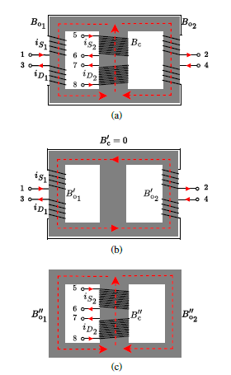
Fig. 5. The proposed integrated transformer during the two phases of the converter, with the flux density components in each leg illustrated in (a). (b) is the flux density contribution by $N_{12}-N_{34}$ during the first active phase, while (c) is the flux density contribution by $N_{56}-N_{78}$ during the second active phase.

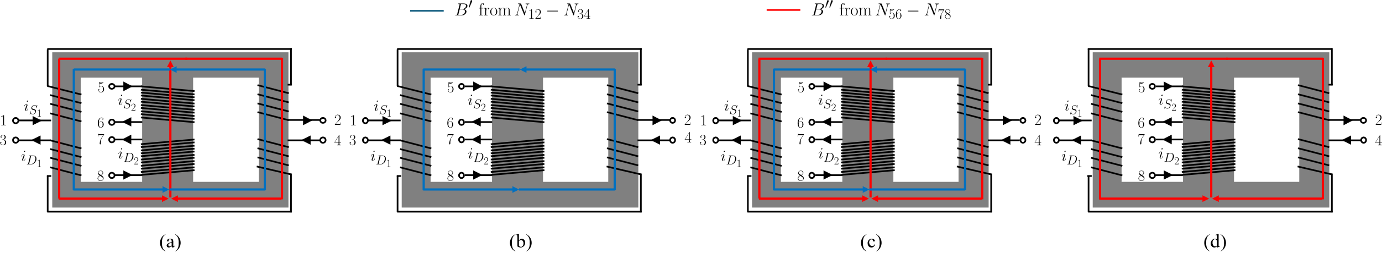
Fig. 6. Magnetic flux paths in the proposed integrated transformer across the six operating modes. (a) Mode 1 ($t_{1}<t<t_{2}$): Phase 1 is charging and Phase 2 is discharging, resulting in the coexistence of $B'$ and $B''$. (b) Modes 2 and 3 ($t_{2}<t<t_{4}$): Phase 1 is solely active, demonstrating perfect flux cancellation in the center leg. (c) Mode 4 ($t_{4}≤t<t_{5}$): Phase 2 is charging and Phase 1 is discharging, with both $B'$ and $B''$ present. (d) Modes 5 and 6 ($t_{5}<t<t_{7}$): Phase 2 is solely active.

1) Mode 1 ($t_{1}<t<t_{2}$, Fig. 3(a)): At time $t_{1}$, switch $S_{1}$ turns on and $S_{2}$ remains off. The transformer $N_{12}-N_{34}$ begins storing energy in its magnetizing inductance. Its magnetizing current $i_{Lm1}$ and the corresponding flux densities in the outer legs $B'_{o1}$ and $B'_{o2}$ linearly increase from zero. Simultaneously, transformer $N_{56}-N_{78}$ completes its discharge phase, with its magnetizing current $i_{Lm2}$ and secondary diode current $i_{D2}$ decreasing to zero at $t_{2}$. During this overlap interval, the magnetic fluxes from both transformers coexist in the core, as illustrated in Fig. 6(a). Because Phase 2 is still discharging, flux $B''$ remains present in the center leg.

(after mode 3)
Transformer $N_{12}-N_{34}$ operates as follows. The magnetomotive force and magnetic resistance of both outer legs for $N_{12}-N_{34}$ are equal. This causes the magnetic flux from the outer legs that flow into the center leg to be canceled. This causes no electromotive force generated in transformer $N_{56}-N_{78}$. As illustrated in Fig. 6(b), during Modes 2 and 3, the flux solely flows on the outer legs. Therefore, the transformer formed by the outer legs operates independently from the transformer in the center leg. The equivalent magnetic circuit for these modes is shown in Fig. 7(a).

4) Mode 4 ($t_{4}<t<t_{5}$, Fig. 3(d)): Mode 4 operates similarly to the positive cycle. Switch $S_{2}$ turns on at $t_{4}$ and $S_{1}$ remains off. Transformer $N_{56}-N_{78}$ stores energy in its magnetizing inductance. Its current $i_{Lm2}$ and the corresponding flux densities $B''_{o1}$, $B''_{c}$ and $B''_{o2}$ linearly increase. Simultaneously, transformer $N_{12}-N_{34}$ completes its discharge phase, with $i_{Lm1}$ and $i_{D1}$ decreasing to zero at $t_{5}$. Similar to Mode 1, this overlapping period results in the coexistence of both flux paths $B'$ and $B''$, as shown in Fig. 6(c).

(after mode 6)
Transformer $N_{56}-N_{78}$ operates as follows. The magnetic resistance of both outer legs is equal, causing the magnetic flux from the center legs to be divided equally into both outer legs. Since the number of turns of both outer legs is equal and wound in an opposite polarity, the electromotive force generated in $N_{12}-N_{34}$ is canceled. As illustrated in Fig. 6(d), during Modes 5 and 6, only the flux from the center legs flows through the transformer. Therefore, the transformer formed by the center leg operates independently from the transformer in the outer leg, and the equivalent magnetic circuit for this case is shown in Fig. 7(b).

- If, Mode1,2,3 are for +ve half cycle and mode 4,5, 6 are for negetive half cycle then can we represent the B01′ and B01′′ in the same time line graph??(Ref: Fig:4) Its difficult to understand.
Thank you for your comment. We apologize for the confusing terminology in the manuscript. The terms “positive” and “negative” cycle were chosen to describe the high-frequency interleaved switching phases, inadvertently implying AC line-frequency half-cycles. In reality, the two phases operate 180$°$ out of phase with the same T_{s}, meaning that they function in the same timeline. The explanation of the mode analysis was meant to be during a quasi-static switching event.

The reason for separating the graphs in Fig. 4 is to merely denote which flux component, $B’$ or $B’’$, is generated by the active transformer in each respective phase. The fluxes contributed by the transformer active in Phase 1 ($N_{12}-N_{34}$) are denoted by $B'$, with the flux in the center, left, and right leg denoted as $B_{c}^{'}$, $B_{o1}^{'}$, or $B_{o2}^{'}$ respectively, before they are super-positioned in the core. The gate-source voltage, magnetizing current, switch current, and diode current during this phase are denoted as $v_{gs_{1}}$, $i_{L_{m_{1}}}$, $i_{S_{1}}$ and $i_{D_{1}}$. Similarly, the relevant quantities contributed by the transformer active in Phase 2 ($N_{56}-N_{78}$) are denoted by ${B'}_{c}^{'}$, ${B'}_{o1}^{'}$, or ${B'}_{o2}^{'}$ for the fluxes, and $v_{gs_{2}}$, $i_{L_{m_{2}}}$, $i_{S_{2}}$ and $i_{D_{2}}$ for the voltages and currents. We have rigorously revised the terminology in Section II, replacing "positive/negative AC input" with "Phase 1 active period" and "Phase 2 active period," and added a clarifying note to Fig. 4 to explain the timeline mapping. We have also revised Figure 3(d) to 3(f), to reflect the quasi-static switching event.
Before revision | After revision
(3rd paragraph of section II)  The operational principle of the rectifier with the proposed transformer is illustrated in Fig. 3. Additionally, Fig. 4 presents the key waveforms of the six distinct operation modes….. | (3rd paragraph of section II)  The operational principle of the rectifier with the proposed transformer is illustrated in Fig. 3. Additionally, Fig. 4 presents the key waveforms of the six distinct operation modes. The operation modes are examined under six-time intervals relative to the switching period of S₁. …
(4th paragraph of section II)  To describe the magnetic state of the core, the superposition principle is used, as shown in Fig. 5(a). The magnetic flux density component B’ is generated by the positive cycle transformer defined as N₁₂ −N₃₄. The magnetic flux density component B’’ represents the component generated by the negative cycle transformer defined as N₅₆ −N₇₈. The total flux in any leg is the algebraic sum of these components. This superposition determines the peak flux density required for the core design, which is analyzed in detail in Section II-B. | (4th paragraph of section II)  To describe the magnetic state of the core, the superposition principle is used, as shown in Fig. 5(a). The magnetic flux density component B’ is generated by the transformer active in the first phase defined as N₁₂ −N₃₄. The magnetic flux density component B’’ represents the component generated by the transformer active in the second phase defined as N₅₆ −N₇₈. The total flux in any leg is the algebraic sum of these components. This superposition determines the peak flux density required for the core design, which is analyzed, which is analyzed in detail in Section II-B.
(5th paragraph of section II)  Modes 1, 2, and 3 in Figs. 3(a)-(c) cover the operation during the positive AC input into the rectifier, while Modes 4, 5, and 6 in Figs. 3(d)-(f) describe the operation during the negative AC input. For the following modes, B’_{o1}, B’_{o2}, and B’_{c} represent the magnetic flux densities in the respective left, right, and center legs of the core caused by the transformer active in positive AC input N₁₂−N₃₄, respectively, which are shown in Fig. 5(b). On the other hand, B’’_{o1}, B’’_{o2}, and B’’_{c} represent the magnetic flux densities in the respective left, right, and center legs of the core caused by the transformer active in negative AC input N₅₆ − N₇₈, respectively, which are detailed visually in Fig. 5(c). | (5th paragraph of section II)  Modes 1, 2, and 3 in Figs. 3(a)-(c) cover the operation during the first active phase, while Modes 4, 5, and 6 in Figs. 3(d)-(f) describe the operation during the second active phase. The six modes are examined under the switching period T_{s} of S₁. For the following modes, B’_{o1}, B’_{o2}, and B’_{c} represent the magnetic flux densities in the respective left, right, and center legs of the core caused by N₁₂−N₃₄, respectively, which are shown in Fig. 5(b). On the other hand, B’’_{o1}, B’’_{o2}, and B’’_{c} represent the magnetic flux densities in the respective left, right, and center legs of the core caused by N₅₆−N₇₈, respectively, which are detailed visually in Fig. 5(c).
(in Section II-A, at the operational mode analysis)  …The peak primary current in the positive cycle $i_{S_{1_{pk}}}$ is given by (2)...  …The peak primary current in the negative cycle $i_{S_{2_{pk}}}$ is given by (4)... | (in Section II-A, at the operational mode analysis)  …the time-variant peak primary current $i_{S_{2_{pk}}}\left(t\right)$ reached at the end of the ON-time of the second active phase is given by (2):  …the time-variant peak primary current $i_{S_{2_{pk}}}\left(t\right)$ reached at the end of the ON-time of the second active phase is given by (4):
(Caption of Fig. 4)  Fig. 4. Key waveforms in the operation of the two-phase interleaved flyback rectifier with the proposed transformer, with $D≤0.5\frac{nV_{O}}{V_{in_{max}}}$. | (Caption of Fig. 4)  Fig. 4. Key waveforms in the operation of the two-phase interleaved flyback rectifier with the proposed transformer, with $D≤0.5\frac{nV_{O}}{V_{in_{max}}}$. S₁ and S₂ operate 180$°$ out of phase and have the same $T_{s}$. The flux densities $B^{'}$ and $B^{''}$ represent the individual, un-superimposed magnetic flux components generated in the first and second active phase by $N_{12}-N_{34}$ and $N_{56}-N_{78}$ respectively.

Before revision | After revision
(in Section II, Fig. 3)  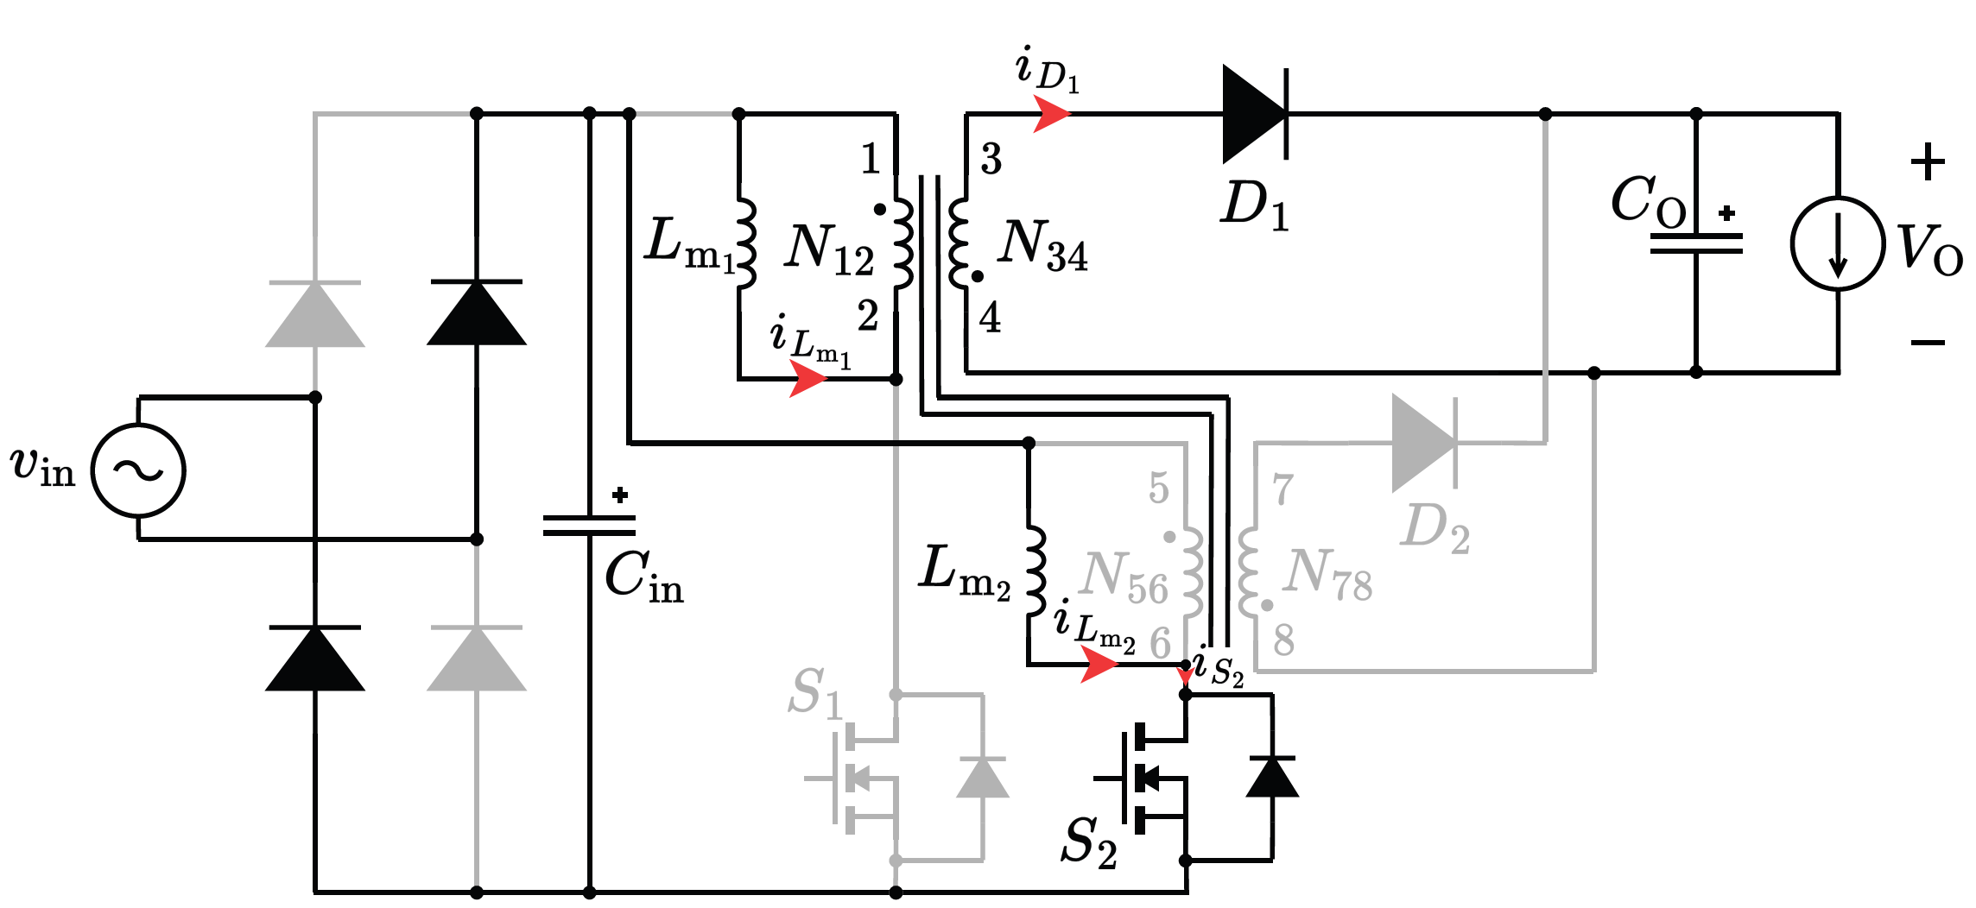  (d)  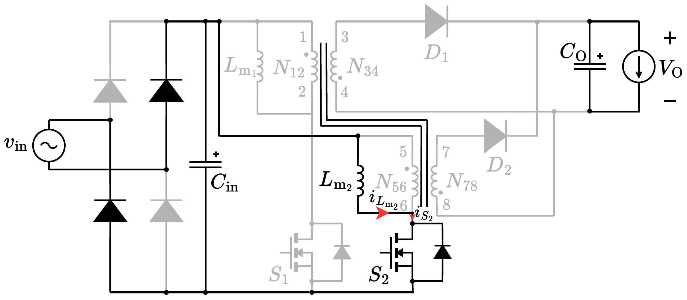  (e)  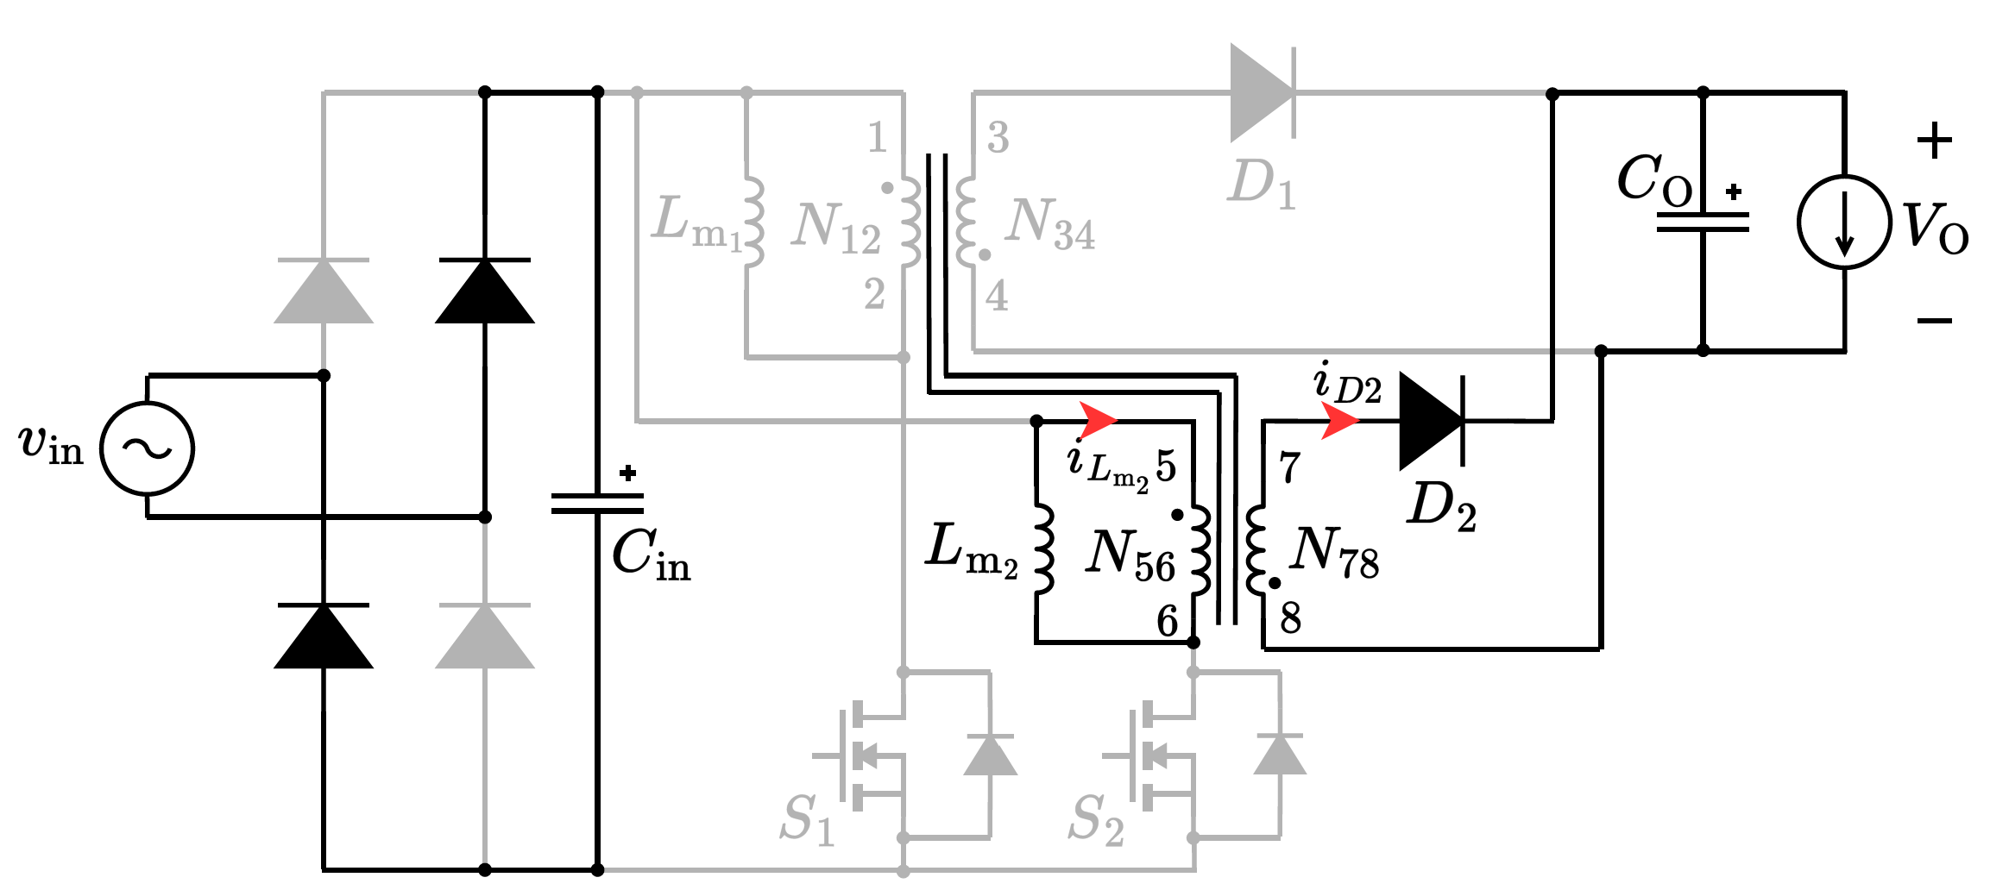  (f)  Fig. 3. Operational principle of the two-phase interleaved flyback rectifier with the proposed integrated transformer at $D≤0.5\frac{nV_{o}}{V_{in,max}}$. There are six distinct operational modes shown: (a) Mode 1 ($t_{1}<t<t_{2}$), (b) Mode 2 ($t_{2}<t<t_{3}$), (c) Mode 3 ($t_{3}<t<t_{4}$), (d) Mode 4 ($t_{4}<t<t_{5}$), (e) Mode 5 ($t_{5}<t<t_{6}$), and (f) Mode 6 ($t_{6}<t<t_{7}$). | (in Section V, Fig. 15)  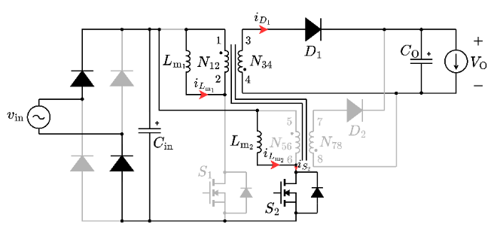  (d)  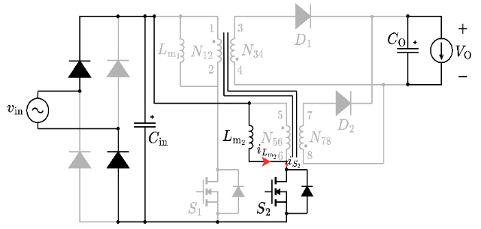  (e)  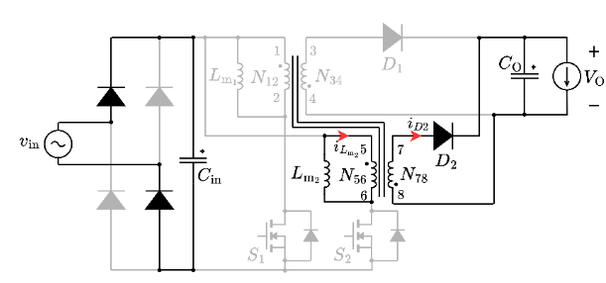  (f)  Fig. 3. Operational principle of the two-phase interleaved flyback rectifier with the proposed integrated transformer at $D≤0.5\frac{nV_{o}}{V_{in,max}}$. There are six distinct operational modes shown: (a) Mode 1 ($t_{1}<t<t_{2}$), (b) Mode 2 ($t_{2}<t<t_{3}$), (c) Mode 3 ($t_{3}<t<t_{4}$), (d) Mode 4 ($t_{4}<t<t_{5}$), (e) Mode 5 ($t_{5}<t<t_{6}$), and (f) Mode 6 ($t_{6}<t<t_{7}$).
- Some portions of the manuscript appear repetitive. The presentation could be improved by consolidating overlapping discussions and avoiding redundancy.
Thank you for the comments. We agree that some portions of the manuscript seem to be too long or repetitive at some point. In conjunction with the other comments, some parts of the text have been revised to make the whole text more clear and streamlined.

- Please provide a more detailed explanation of the mechanism by which the proposed topology improves light-load efficiency. Quantitative results would strengthen the discussion.
Thank you for your comment. In some coupled flyback topologies that cannot operate independently, utilizing phase-shedding at light loads induces voltages across the inactive phase, generating circulating currents that severely degrade light-load efficiency. Because our proposed integrated transformer inherently features zero magnetic coupling between phases, the active phase causes no magnetic interference in the inactive phase. Thus, the converter can seamlessly deactivate one phase at light loads without suffering from induced circulating currents. Therefore, we believe that our topology can contribute to improved light-load efficiency by providing a way for decoupling the two phases.

While we agree that quantitative results would further strengthen this discussion, an exhaustive evaluation of light-load efficiency falls outside the primary scope of this research. The experimental prototype developed for this study was specifically designed to validate the proposed magnetic integration. Consequently, precise quantitative measurements isolating the efficiency improvements during light-load phase-shedding were not captured. We have, however, clarified the theoretical explanation of this decoupling mechanism in the revised manuscript and noted the quantitative optimization of light-load operation as an area for future work.

Before revision | After revision
(5th paragraph of section I)  ...In single-phase operation, when the phases are highly coupled, the active phase inevitably induces a voltage across the inactive phase, generating circulating currents that reduce light-load efficiency [17], [18]. | (5th paragraph of section I)  When mutual coupling exists between windings, the phases influence one another. In some coupled flyback topologies that cannot operate independently, utilizing phase-shedding for single-phase operation at light loads induces a voltage across the inactive phase. This generates circulating currents that degrade light-load efficiency [17], [18].

- Strengthen the litreture survey and refrences.
Thank you very much for your comment. Please see the response to Question 9.

To Reviewer 3
We authors appreciate your valuable comments. The revised parts are indicated by red texts in the manuscript.
Comments to the Author
This paper analyzes the design and implementation of an interleaved Flyback converter based on magnetic integration. My comments are as follows:
- The efficiency of the converter is a very important indicator. The paper should include the efficiency curve of the converter, as well as the efficiency comparison with the interleaved Flyback converter without magnetic integration, and also the efficiency comparison analysis with other similar converters.
We sincerely thank the reviewer for pointing this out. We completely agree that efficiency is a fundamental metric for evaluating standard converter topologies. We have experimentally measured the efficiency of the converter over its entire operating range, up to an input power of 250 W using a Hioki PW8001 Power Analyzer. The resulting efficiency curve, shown in the figure below, has been added to the revised manuscript as a new figure Fig. 18. The efficiency peaks approximately 84.6% near full load in two-phase drive, and is discussed in the newly added Section V-C. A direct experimental efficiency curve for the conventional discrete setup was not included, as this physical prototype was constructed strictly as a proof-of-concept to validate the magnetic decoupling principle as an integrated transformer. Consequently, while the current prototype demonstrates stable operational performance, it has not yet undergone comprehensive core and winding optimization. We anticipate that the overall efficiency can be further improved in future iterations.

Finally, regarding the comparison with other similar converters, because experimental efficiencies across different literature prototypes are heavily influenced by the specific selection of semiconductor devices, the control method, and snubber optimizations, we cannot make a fair comparison. Our comparison instead focuses on the decoupling methods implemented compared to other solutions. focuses primarily on the fundamental structural advantages of our approach: the improvement in magnetic power density through 16% core volume reduction and the validation of magnetic decoupling within a single EE-core.

Before revision | After revision
N/A | C. System-level Efficiency of the Proposed Interleaved Flyback Rectifier with the Integrated Transformer  To evaluate the overall performance of the proposed topology, the system-level efficiency of the prototype converter was measured over a wide operating range up to an input power of 250 W. The input and output power measurements were recorded utilizing a Hioki PW8001 Power Analyzer. Fig. 18 illustrates the measured efficiency curve during two-phase interleaved operation. As shown, the converter achieves a peak efficiency of approximately 84.6% near full load.  Fig. 18. Efficiency curve of the proposed interleaved flyback rectifier with the integrated transformer, up to full-load operation of 240 W.

- The modulation results of the interleaved converter are not mentioned in the paper, especially the experimental results.
Thank you for your valuable feedback. The operating principles of the converter, even with the proposed integrated transformer, are not changed from a conventional setup. Because the fundamental electrical operation is exactly the same as a conventional interleaved flyback PFC rectifier operating in discontinuous current mode (DCM), standard modulation methods are directly applicable. Therefore, we did not write extensively about the modulation method or include specific closed-loop modulation results, as our primary focus was validating the magnetic decoupling characteristics of the transformer itself. We then performed our experimental tests using open-loop control with a fixed duty cycle.

We then performed our experimental tests using open-loop control with a fixed duty cycle. To avoid confusion, we revised the manuscript of Section V-A to clarify the scope of our experimental validation. The revised portion of Section V-A is also in our response to Comment #5.

- The volume advantage brought by magnetic integration needs to be further explained, and the benefits brought by magnetic integration should be explained by comparison.
We thank the reviewer for this insightful comment. In terms of the

We thank the reviewer for this insightful comment.

In terms of the losses, because the electrical operation is decoupled and remains identical to a discrete setup, we expect that the semiconductor switching and conduction losses (from the MOSFETs and diodes) will be essentially identical to those of a conventional configuration. The efficiency differences lie entirely within the integrated transformer. For the transformer losses, extracting an exact loss breakdown (e.g. separating core and winding losses) from the physical prototype is challenging without highly specialized calorimetric measurement setups. Moreover, the physical prototype was constructed strictly as a proof-of-concept to validate the magnetic decoupling principle as an integrated transformer. Consequently, while the current prototype demonstrates stable operational performance, it has not yet undergone comprehensive core and winding optimization.

We can, however, provide a qualitative explanation of the magnetic loss mechanisms compared to a conventional discrete setup. The dimensions of the integrated transformer and discrete transformers in the ideal situation where components can be custom-made and precision is not a problem are obtained using the area products calculated in Section IV, which has been revised to reflect the latest changes in terms of depth of explanation and calculation.

Core Loss Considerations:
In a conventional discrete setup, the flux density remains uniform across isolated magnetic paths. In the proposed integrated core, the shared flux paths result in a complex flux distribution due to the superposition of individual phase contributions, as illustrated in Fig. 7. During overlapping conduction intervals, this superposition creates localized regions of high flux density (additive flux, increasing ΔB) in one outer leg, but conversely creates regions of reduced flux density (subtractive flux) in the other outer leg. Because ferrite core loss scales non-linearly with flux density, the net impact on the total core loss involves both positive and negative components. Determining whether the overall core loss is strictly higher or lower than a discrete setup requires extensive finite element analysis (FEA) and volumetric loss integration, which remains a subject for future analysis.

Winding Loss Considerations:
The physical geometry of the shared EE-core forces a structural asymmetry. To balance the magnetizing inductance across the shared core, the transformer on the outer legs requires an increased turn count. While the outer legs possess a smaller perimeter, which partially offsets the DC resistance penalty of the extra turns, the overall winding losses in this initial proof-of-concept are not yet fully optimized. Achieving parity or superiority in AC resistance R_ac compared to a conventional setup will require extensive parameter sweeps and careful optimization of the winding geometry, which is a primary focus for our future work.

Therefore, we believe that the proposed structure reveals that it currently prioritizes physical miniaturization over maximum efficiency, enabling a 16% reduction in overall magnetic volume. The peak system efficiency of 84.6% demonstrates that before comprehensive magnetic optimization, the converter maintains viable and stable operation.

- As a PFC, more experimental waveforms need to be provided, including the operating condition where the power factor is not 1, the dynamic waveform of the output voltage, etc.
Thank you for your valuable comment. The proposed two-phase interleaved flyback rectifier is designed to operate in Discontinuous Conduction Mode (DCM). A fundamental characteristic of a DCM flyback topology is that it naturally achieves power factor correction (PFC) without requiring a complex, active current-shaping control loop.

When the converter operates with a fixed switching frequency and a constant duty cycle $D$ across the AC line half-cycle, the peak and average currents drawn by each transformer phase during a switching period are directly proportional to the instantaneous rectified input voltage. Because there is no phase shift between the voltage and the drawn current, the total average input current inherently tracks the sinusoidal envelope of the AC input voltage, yielding a high-power factor under open-loop control.

The mathematical derivation confirming this inherent PFC behavior for the two-phase interleaved structure is detailed below:

Given a fixed switching frequency $f_{s}$ over the switching period $T_{s}$ and a constant duty cycle D across the AC line half-cycle, the peak current of the main switch for the first phase, $i_{S1_{pk}}\left(t\right)$, is determined by the instantaneous input voltage and is expressed as:
$$i_{S1_{pk}}\left(t\right)=\frac{v_{in}\left(t\right)DT_{s}}{L_{m}}$$
where $v_{in}\left(t\right)$ is the instantaneous rectified input voltage and $L_{m}$ is the magnetizing inductance of the active transformer phase.

The average input current drawn by the first phase over one switching period is calculated by integrating the triangular switch current waveform:

$$\left\langle i_{S1}\right\rangle \left(t\right)=\frac{1}{T_{s}}\int_{0}^{T_{s}}{i_{S1}}\left(τ\right)dτ=\frac{1}{T_{s}}\left(\frac{1}{2}i_{S1_{pk}}\left(t\right)DT_{s}\right)=\frac{v_{in}\left(t\right)D^{2}T_{s}}{2L_{m}}$$

Because the proposed converter utilizes a two-phase interleaved structure, the second phase operates identically to the first, shifted by 180 degrees. A symmetrical design is utilized in this flyback converter, where both phases share the same $L_{m}$, the average current drawn by the second phase is identical:

$$\left\langle i_{S2}\right\rangle \left(t\right)=\frac{v_{in}\left(t\right)D^{2}T_{s}}{2L_{m}}$$

The total average input current, $\left\langle i_{in}\right\rangle \left(t\right)$, drawn from the rectified input voltage is the sum of the average currents of both active phases:
$$\left\langle i_{in}\right\rangle \left(t\right)=\left\langle i_{S1}\right\rangle \left(t\right)+\left\langle i_{S2}\right\rangle \left(t\right)=\frac{v_{in}\left(t\right)D^{2}T_{s}}{L_{m}}$$
Since $D$, $T_{s}$, and $L_{m}$ are all constant values during steady-state open-loop operation, the total average input current is directly proportional to the instantaneous rectified input voltage:

$$\left\langle i_{in}\right\rangle \left(t\right)∝v_{in}\left(t\right)$$

Because $v_{in}\left(t\right)$ follows a rectified sinusoidal voltage $V_{in_{max}}|\sin\left(2πf_{line}t\right)|$), the input current inherently tracks the sinusoidal shape of the AC mains voltage. Consequently, the converter naturally achieves PFC in DCM without requiring a dedicated active current-shaping control loop. This is seen in the experimental waveform in Fig. 15(a), where we could see from the macroscopic view that $i_{S1}$ and $i_{S2}$ are in-phase with the AC input voltage $v_{in}$ under open loop control.

Consequently, artificially forcing an operating condition where the power factor is not 1, or testing dynamic closed-loop output voltage waveforms, falls outside the scope of verifying this inherent PFC behavior and the primary magnetic decoupling of the transformer. However, we completely agree that this inherent PFC mechanism should be explicitly clear to the readers. We added an appendix detailing the calculation shown above. We expanded the discussion on this matter in Section II-A of the manuscript as follows.

Before Revision | After Revision
N/A | (after the last paragraph of Section II-A)  Because the proposed integrated transformer achieves magnetic decoupling, the fundamental DCM operation of the converter remains electrically identical to a conventional interleaved topology utilizing discrete transformers. As a result, the standard electrical benefits of two-phase interleaving are fully preserved. Utilizing the same fixed $f_{s}$, $D$, and $L_{m}$, the phase currents are governed by identical electrical principles, ensuring that input and output current ripple cancellation is maintained. PFC and Total Harmonic Distortion (THD) are expected to be similar performance expected from a conventional discrete setup.

- Photos of the experimental prototype need to be shown in the paper.
We thank the reviewer for this valuable suggestion. To provide a clearer perspective on the practical implementation, overall footprint, and power density of the proposed converter, we have added a photograph of the evaluation board to the revised manuscript (Fig. 11). As shown in the figure, the primary and secondary side boards of the converter were separated to facilitate simpler connection to the transformer and also experimental verification as there were many probes to be used. The assembly process for the integrated transformer is shown in Fig. 12. Fig. 12(a) shows the actual transformer winding implementation. When winding this transformer, the thicker secondary windings are placed directly on top of the thinner primary windings. This overlapping arrangement minimizes the unused space within the window area and tightly couples the layers, effectively reducing the leakage inductance. The windings are wound around the coil formers first as shown in Fig. 12(b), which were created through the use of a 3D printer, and are finally placed on the EE-core as shown in Fig. 12(c).

Furthermore, to fully clarify the experimental setup, we have explicitly detailed the precision measurement equipment, including the specific power supplies, power analyzer, oscilloscope, and probes utilized, in Section V-A of the revised manuscript.

Before revision | After revision
(Section V-A, 1st paragraph)  A prototype two-phase interleaved flyback rectifier, shown in Fig. 10(a) operating in DCM, was built to verify the operation of the integrated transformer. The prototype integrated transformer, shown in Fig. 10(b), was also designed using the proposed method. The specifications of the two-phase interleaved flyback rectifier and transformer are shown in Tables IV and V, respectively. The transformer parameters were characterized using a Hioki IM3536 LCR meter at 100 kHz. The coupling coefficients of the transformers $k_{N12-N34}$, $k_{N56-N78}$, and $k_{N12-N56}$ were derived from the mutual inductance obtained after connecting the respective transformer windings in series-aiding and series-opposing configurations. The coupling coefficient between the two flyback transformers $k_{N12-N56}$ is 0.0005, showing that the coupling was almost eliminated. | (Section V-A, 1st paragraph to 3rd paragraph)  A prototype two-phase interleaved flyback rectifier, with the circuit schematic shown in Fig. 10(a), was built to verify the operation of the integrated transformer operating in DCM. A photograph of the prototype evaluation board is provided in Fig. 11(a), with the primary and secondary side separated for simple implementation. Because the fundamental operating principles of the converter remain identical to a conventional discrete setup, standard closed-loop modulation methods are directly applicable. Therefore, the experimental evaluation was intentionally conducted using open-loop control with a fixed duty cycle decided using (28).  The prototype integrated transformer, represented in Fig. 10(b), was also designed using the proposed method. To strictly minimize leakage inductance, the primary and secondary windings of the transformer for each respective phase were physically overlapped on their designated legs. The EE-core used for the prototype is shown in Fig. 12(a). The windings are wound around lab-made coil formers, as shown in Fig. 12(b), which were fabricated using a Flashforge Adventurer 4 Series 3D printer, and are finally placed onto the corresponding legs of the core. A photograph of the fully assembled prototype integrated transformer is shown in Fig. 12(c). The specifications of the two-phase interleaved flyback rectifier and transformer are shown in Tables IV and V, respectively.  The comprehensive list of equipment used in the experimental evaluation is summarized in Table VI. Key data was recorded using a Hioki PW8001 power analyzer for system efficiency and power measurements, alongside a Tektronix MSO58 high-definition oscilloscope to capture experimental waveforms. The open-loop PWM signals were generated via a Tektronix AFG31000 Series function generator, and the integrated transformer parameters were characterized using a Hioki IM3536 LCR meter at 100 kHz.  The coupling coefficients of the transformers $k_{N12-N34}$, $k_{N56-N78}$, and $k_{N12-N56}$ were derived from the mutual inductance obtained after connecting the respective transformer windings in series-aiding and series-opposing configurations. The physical overlapping of the windings resulted in high intra-phase coupling coefficients, with $k_{N12-N34}$ measured at 0.970 and $k_{N56-N78}$ at 0.979. Furthermore, the cross-coupling coefficient between the two flyback transformers $k_{N12-N56}$ is 0.0005, showing that the coupling between phases was almost eliminated. Because this decoupling is geometrically enforced by the core and winding arrangement, it is expected to be maintained even under load transient conditions. While severe transients may introduce high-frequency harmonics that slightly degrade this ideal isolation due to parasitic elements, their magnitude and energy are negligible compared to the fundamental operating frequencies, ensuring that the overall dynamic stability of the converter is preserved.

Before revision | After revision
N/A | Fig. 11. Photograph of the evaluation board for the proposed integreated flyback PFC rectifier.
N/A | (a)  (b)  (c)  Fig. 12. Photographs of the proposed integrated transformer: (a) EE-core for the prototype; (b) lab-produced coil formers using a Flashforge Adventurer 4 Series 3D printer; and (c) final assembled prototype, with windings labeled.
N/A

- End of the response letter-

